**SonarCloud aka SonarQube Cloud**

Go to sonarcloud official website: <https://sonarcloud.io/login>

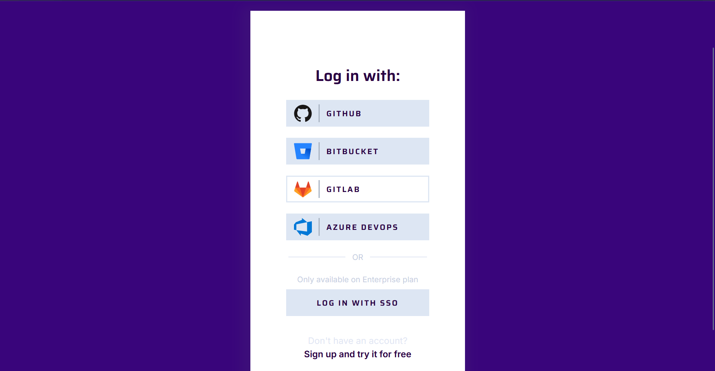

Click Sign up – choose github and authorize github so that sonarcloud can access our repo

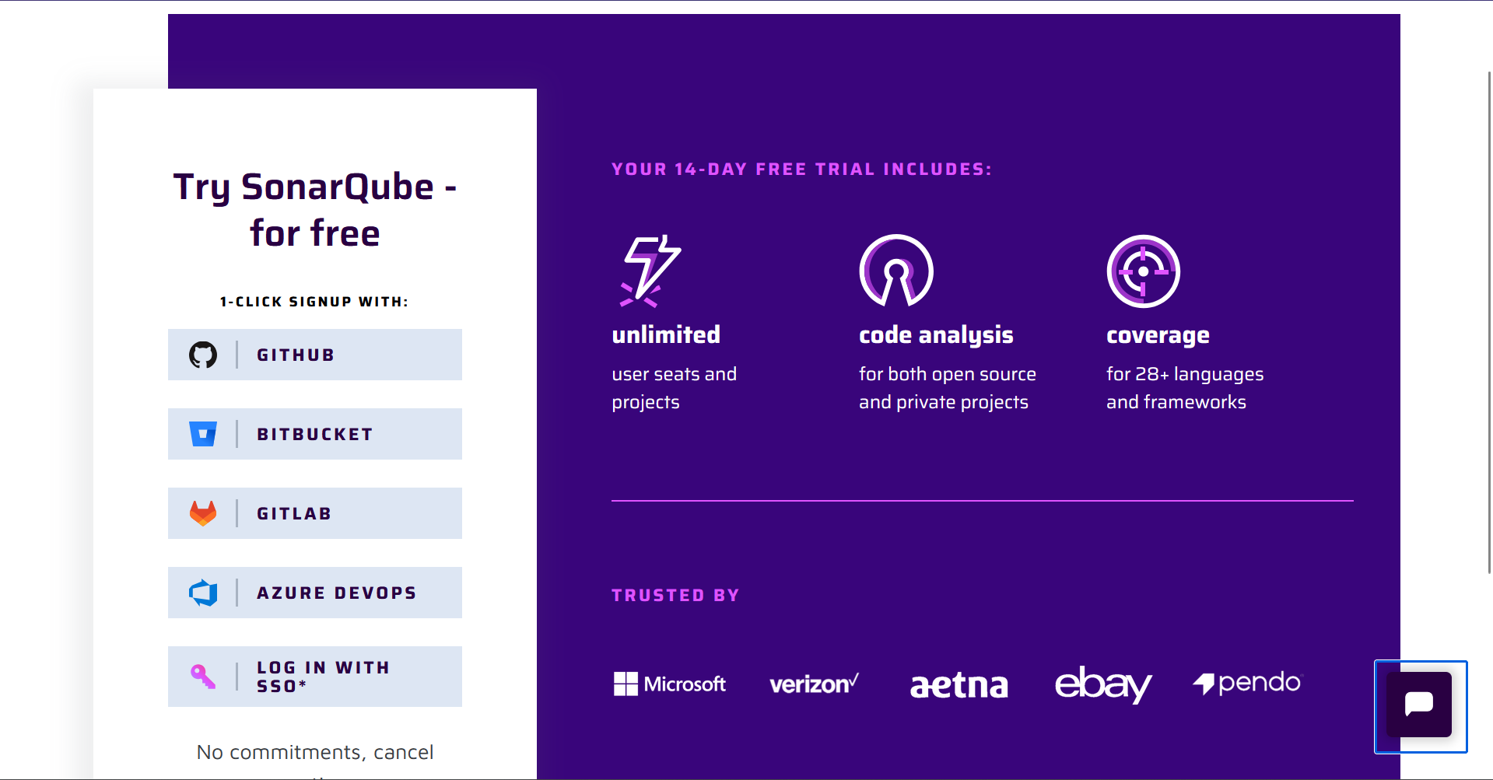

Sign up with github

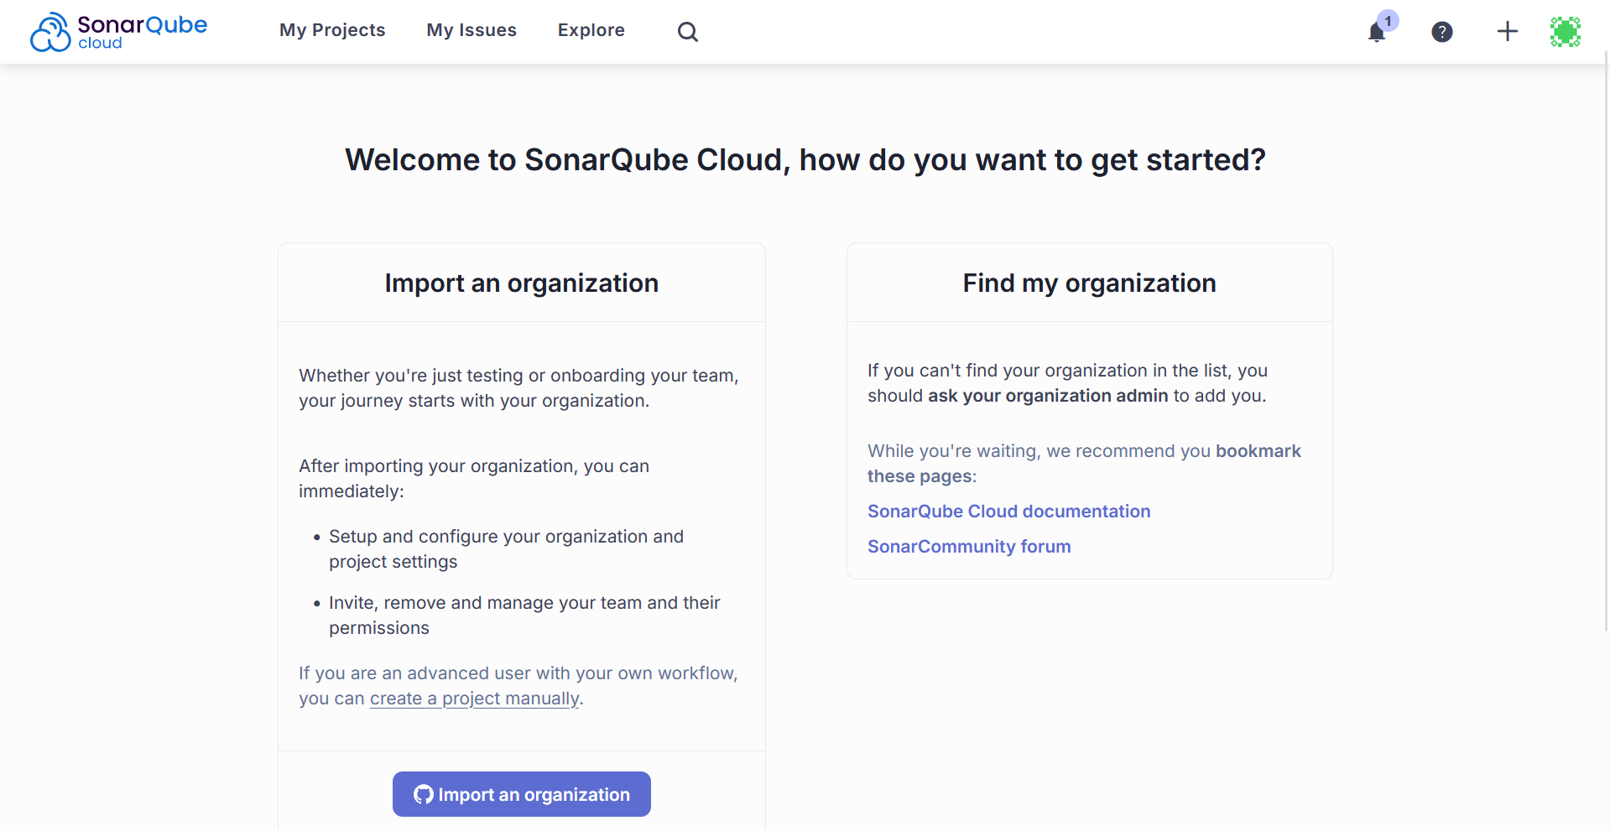

Click on the + sign in the right upper corner -> Click on analyze new project

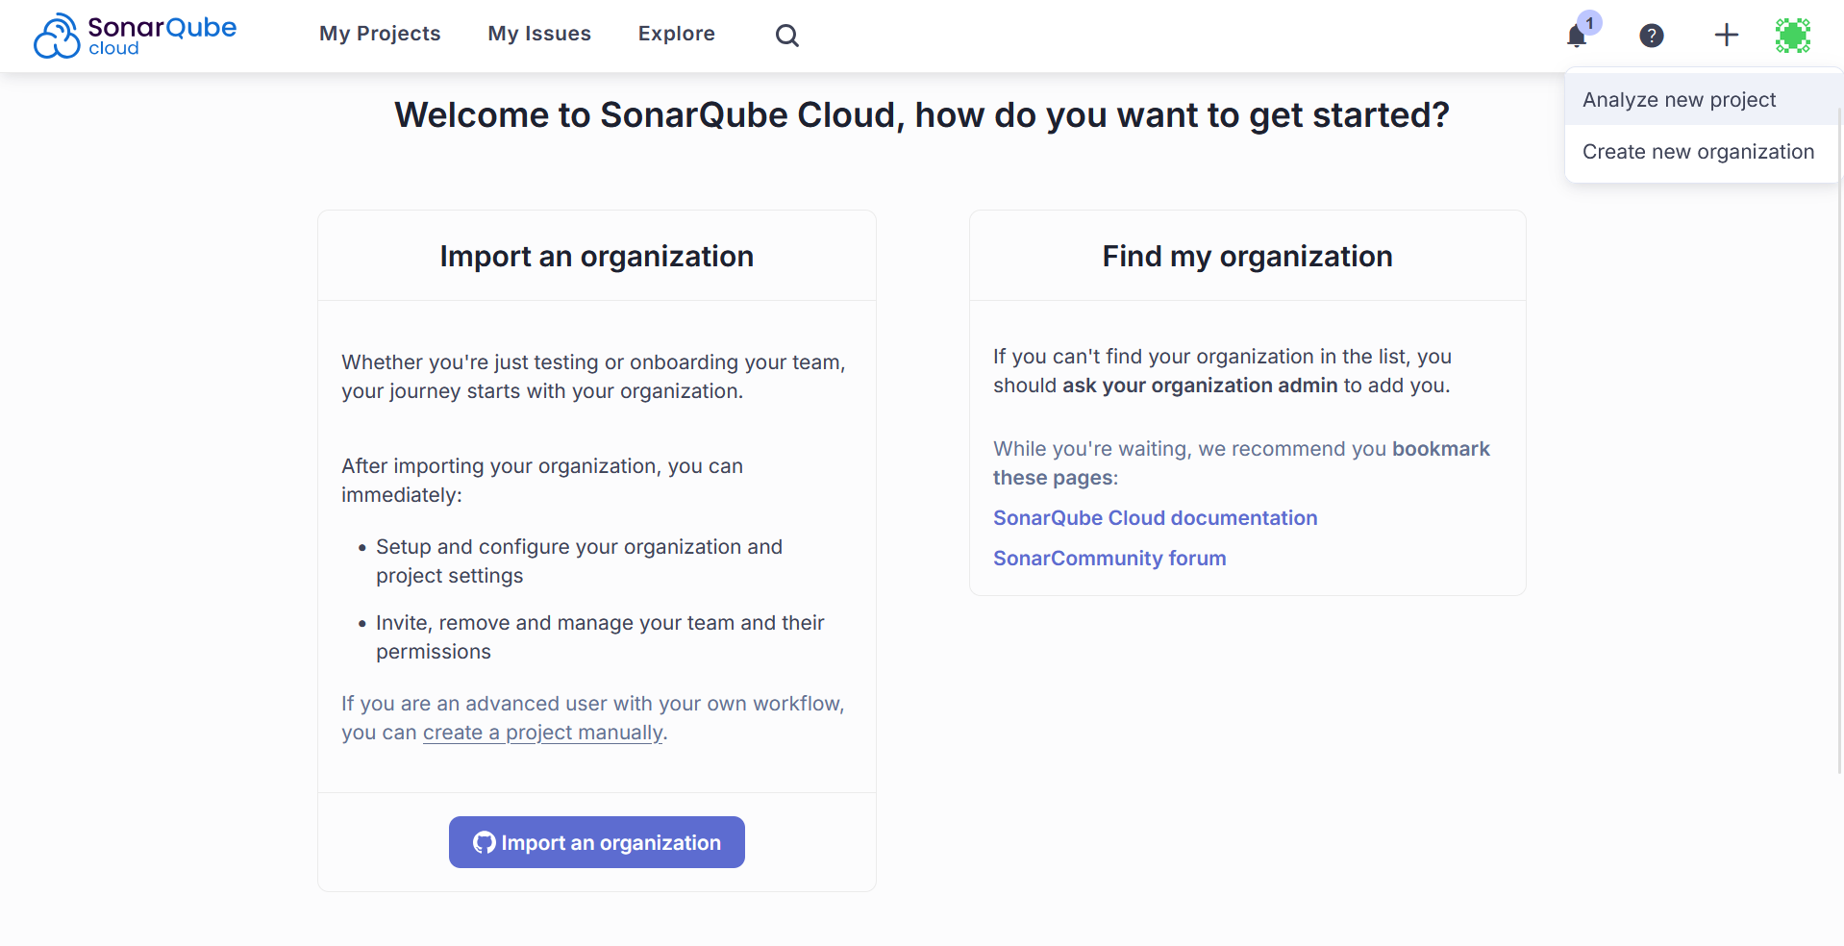

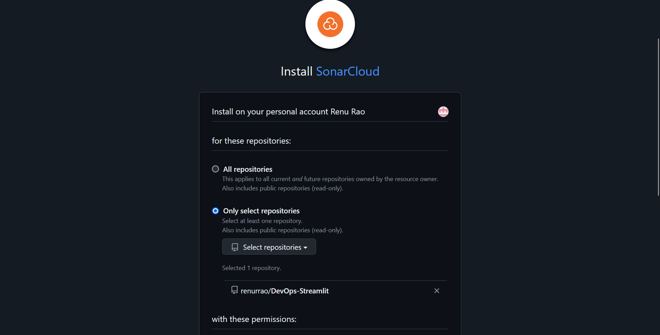

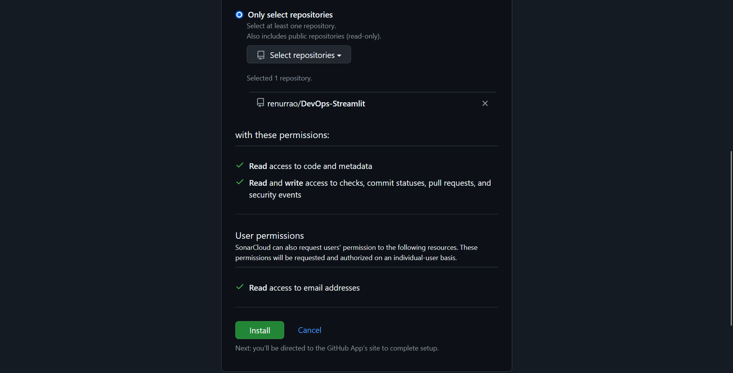

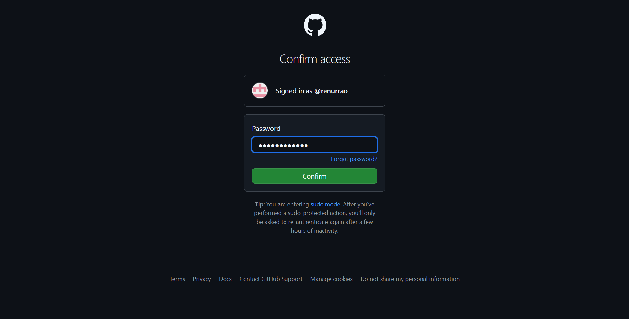

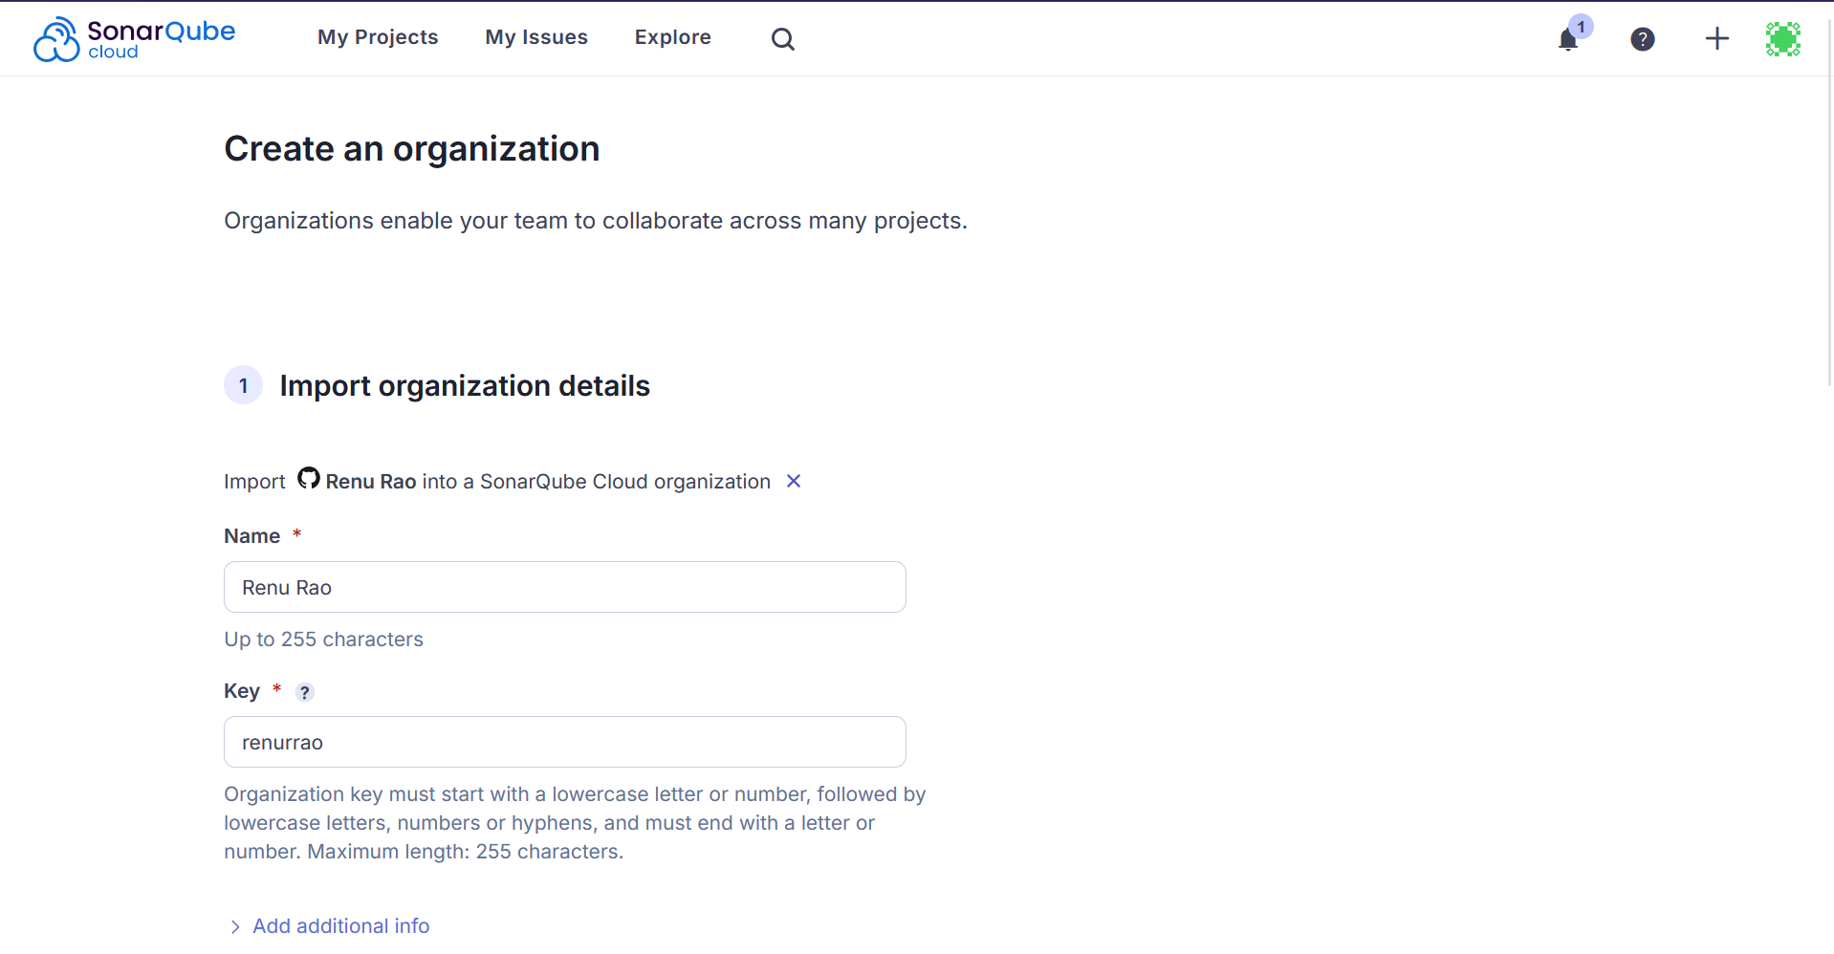

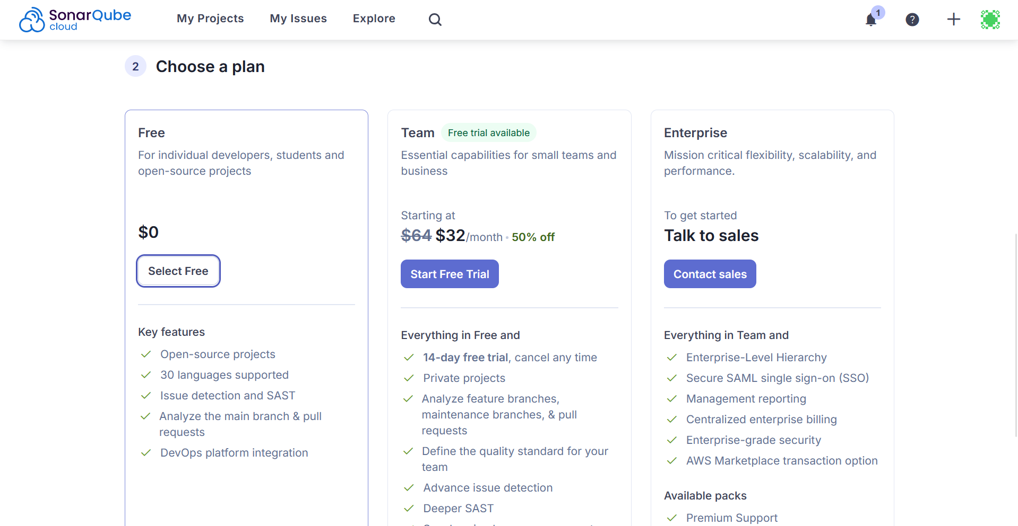

Click on Create Org

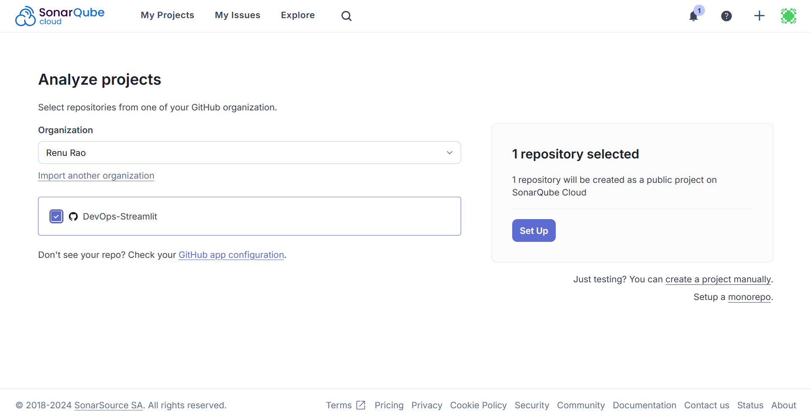

Click Set Up

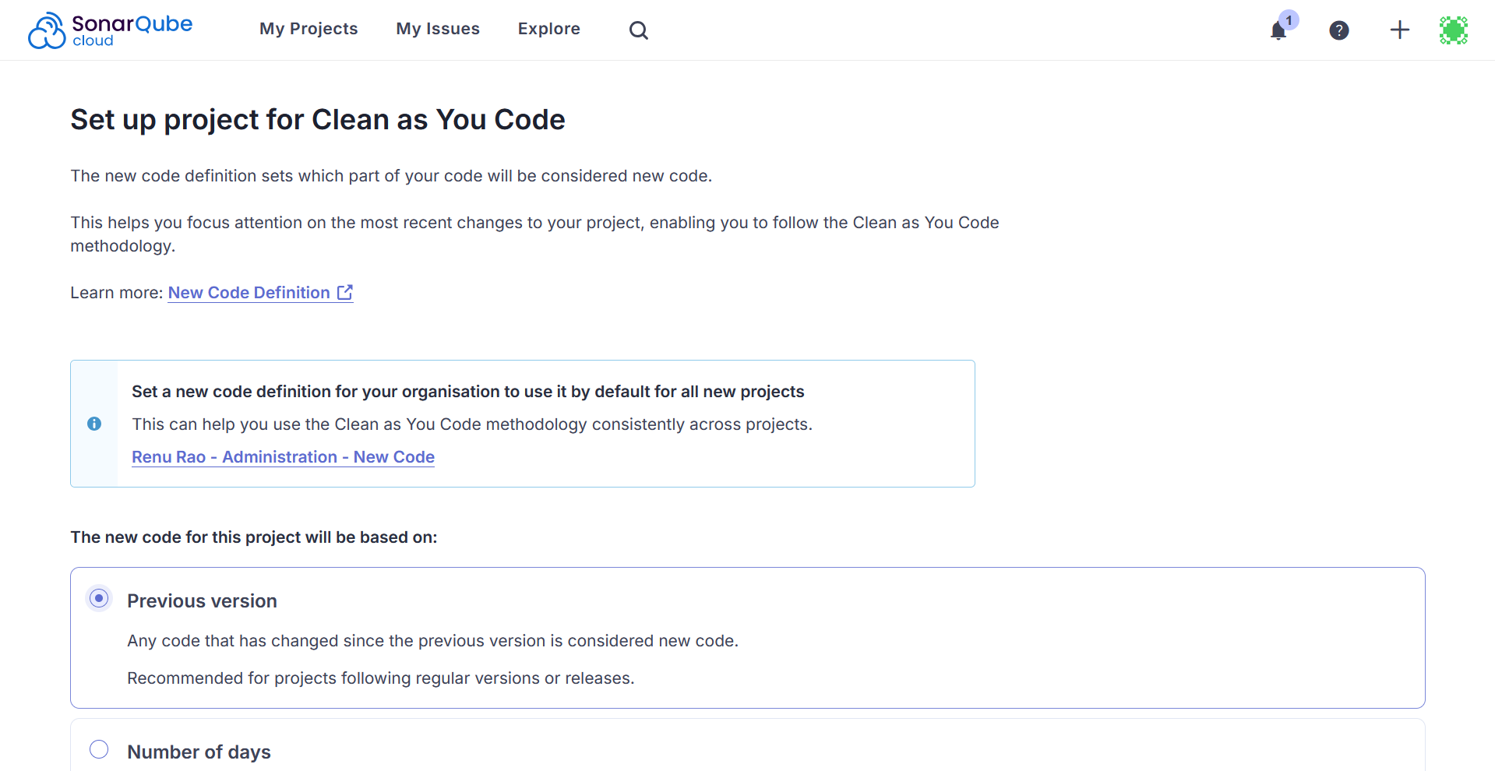

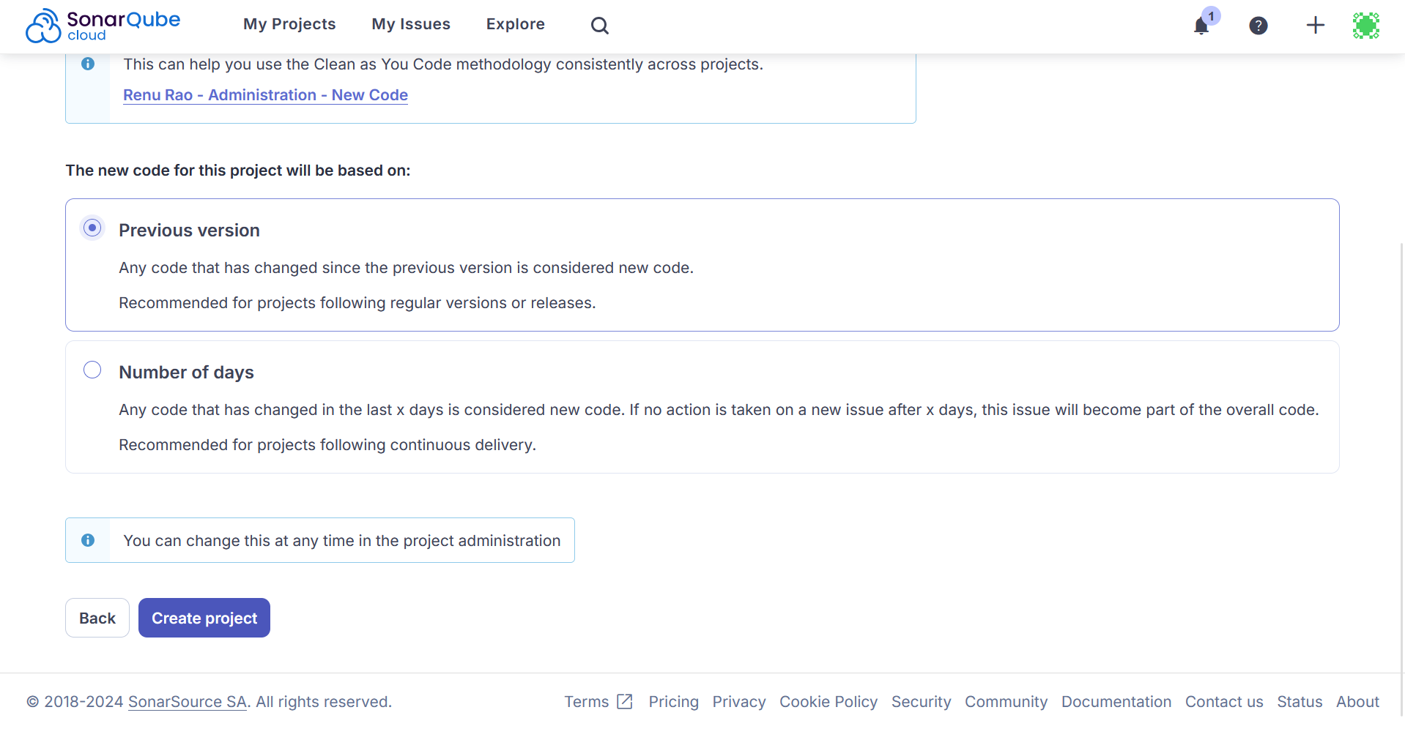

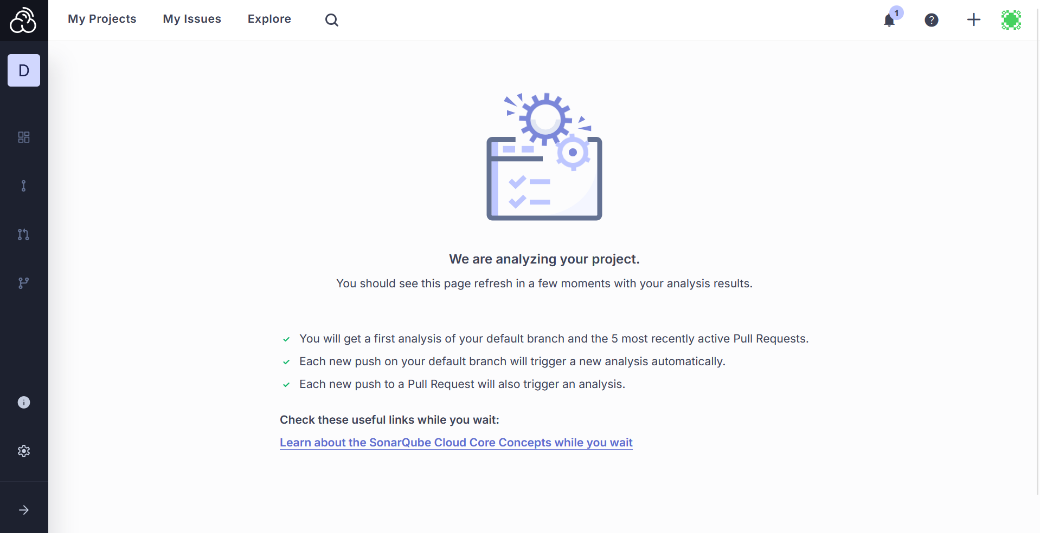

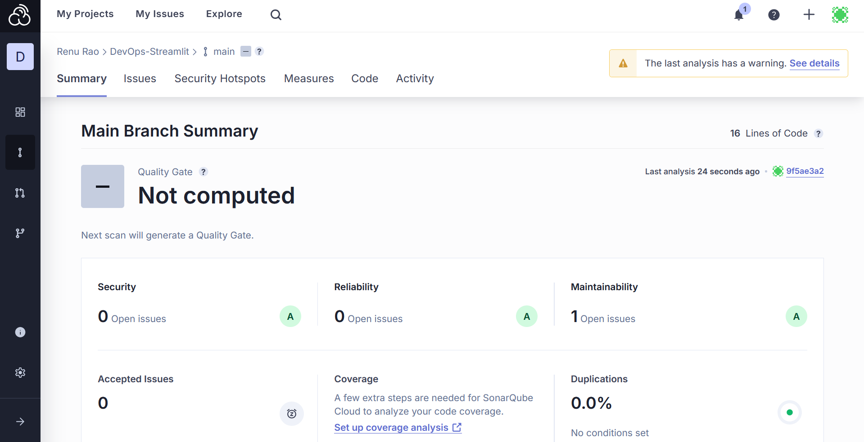

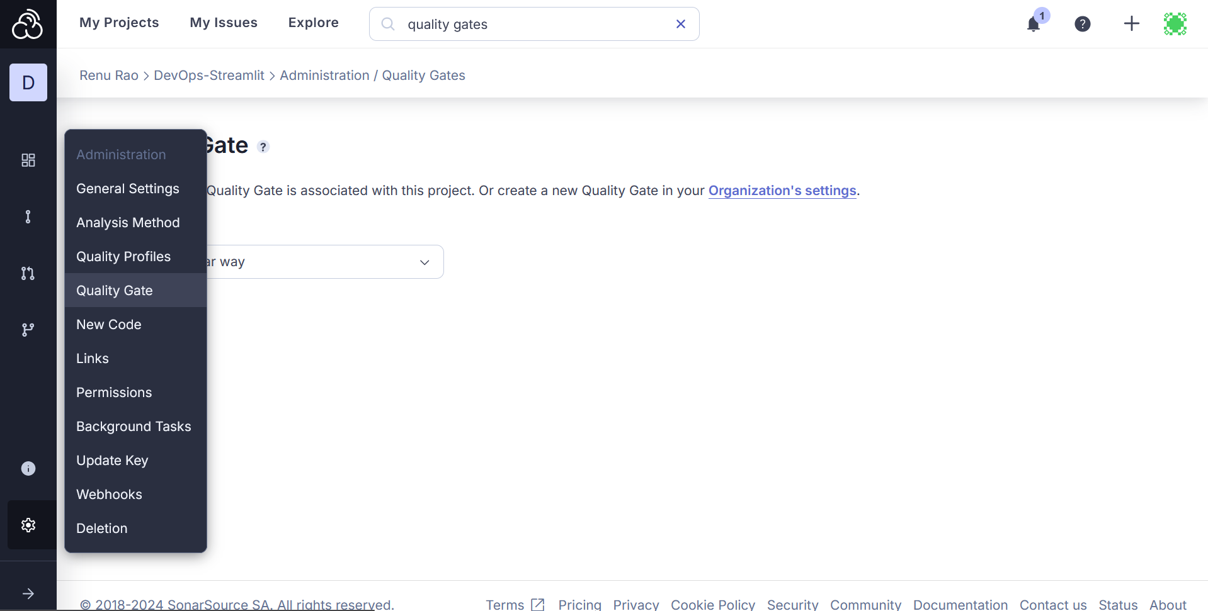

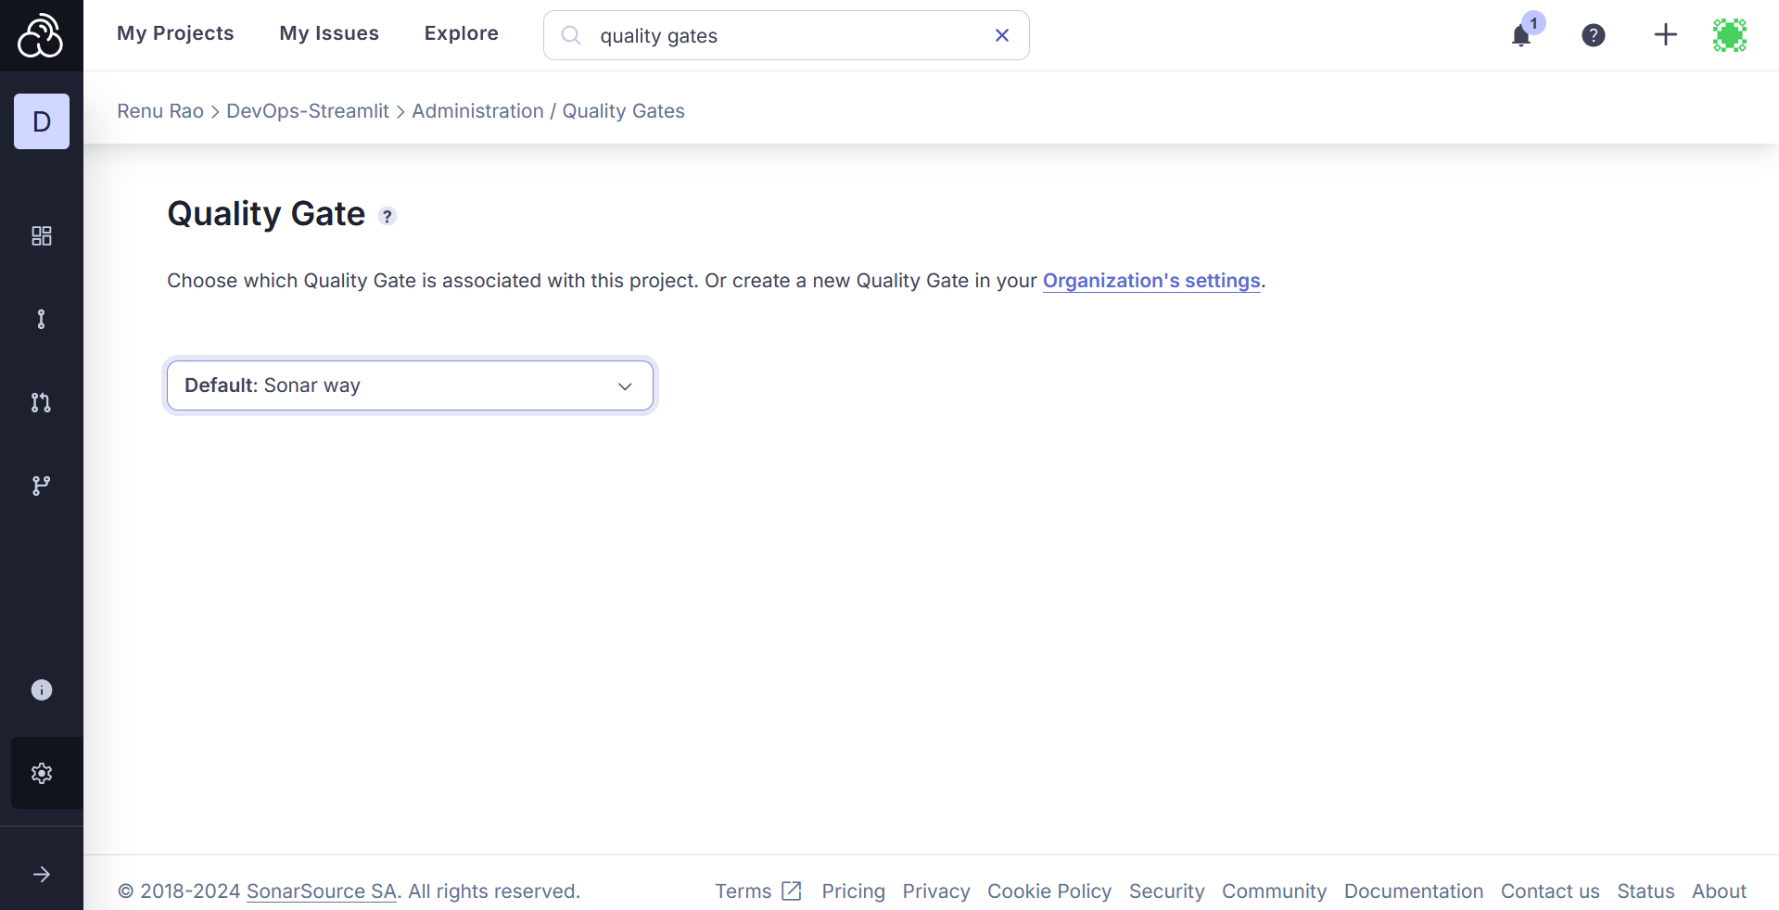

Default is Sonar Way QG. Click on Organization’s Setting (highlighted in abv pic)

Click Create

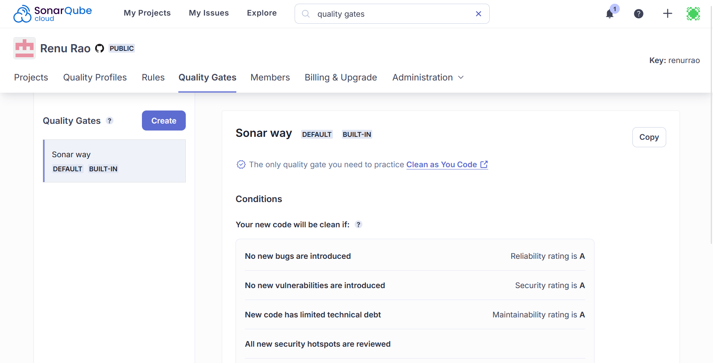

Give the QG a name:

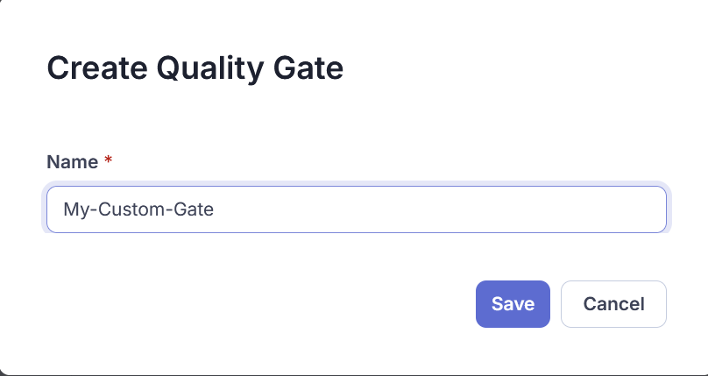

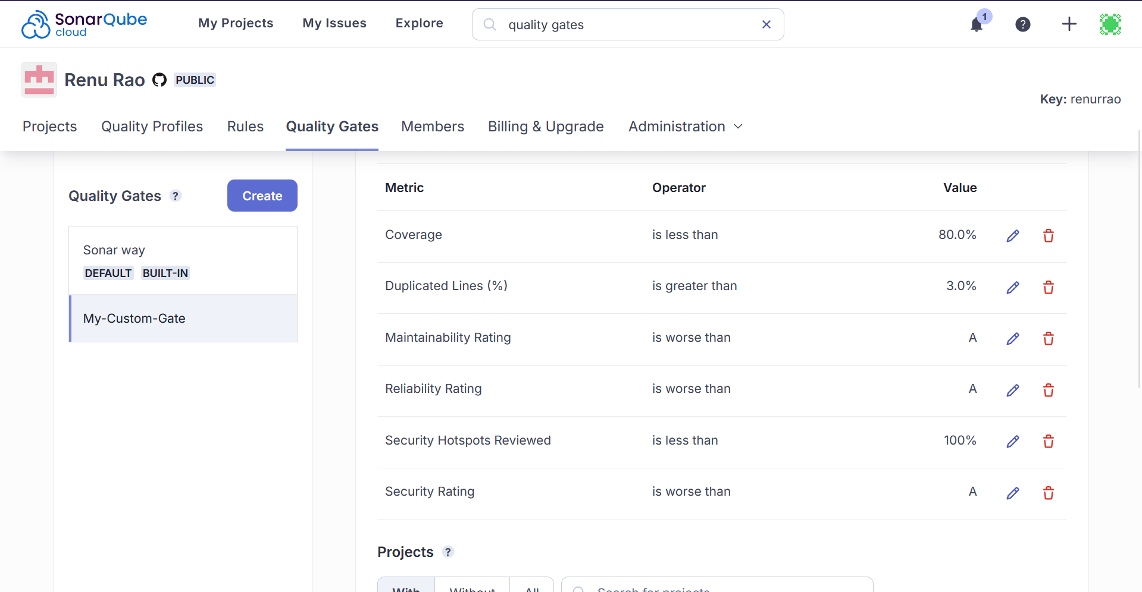

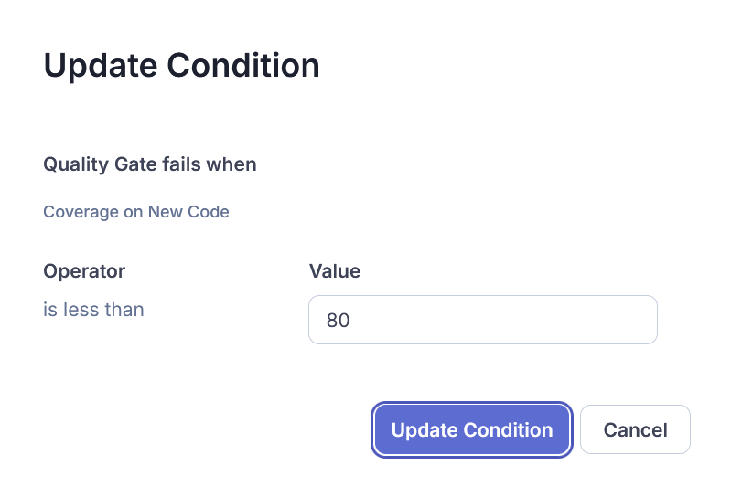

Click on My Projects -> Select your project

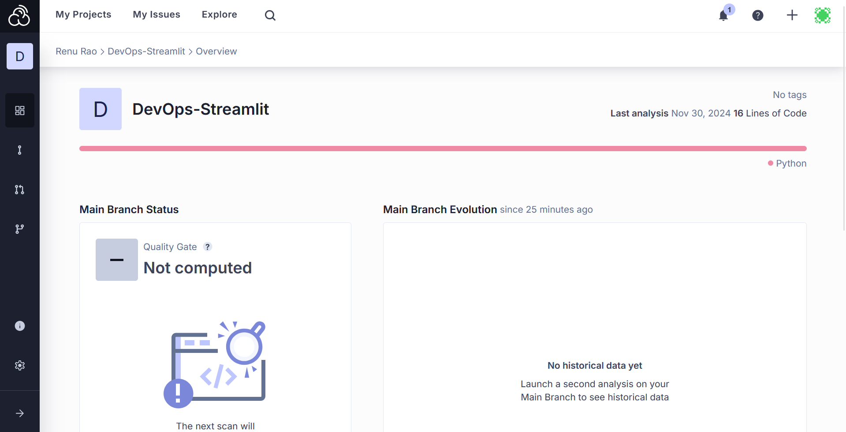

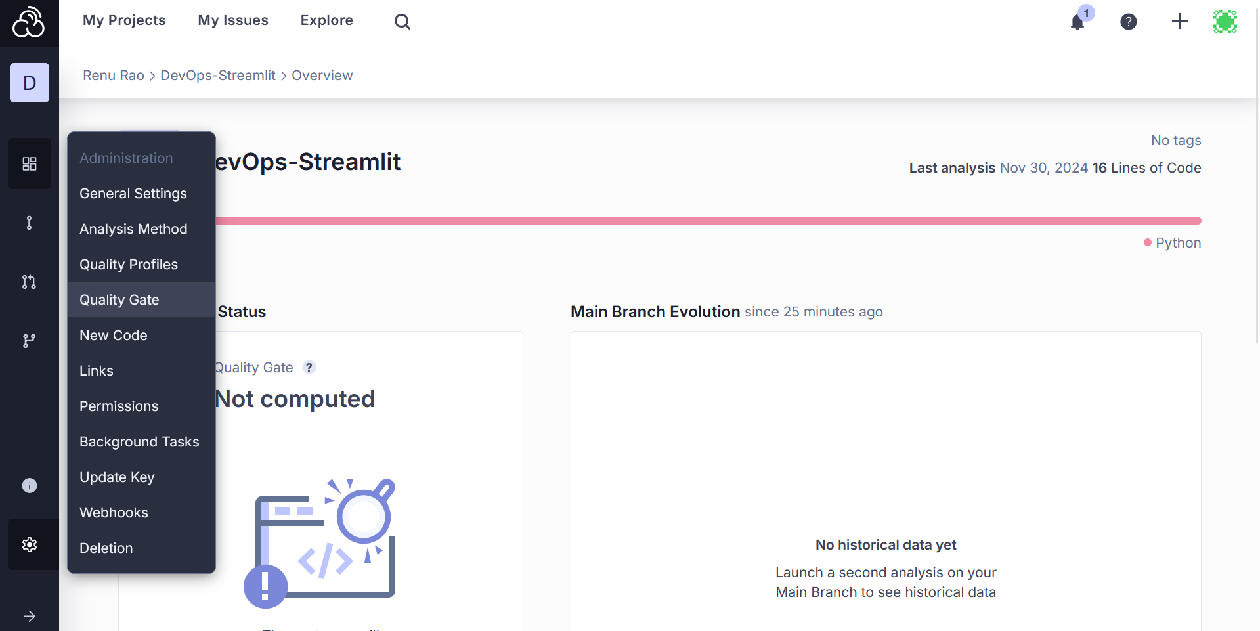

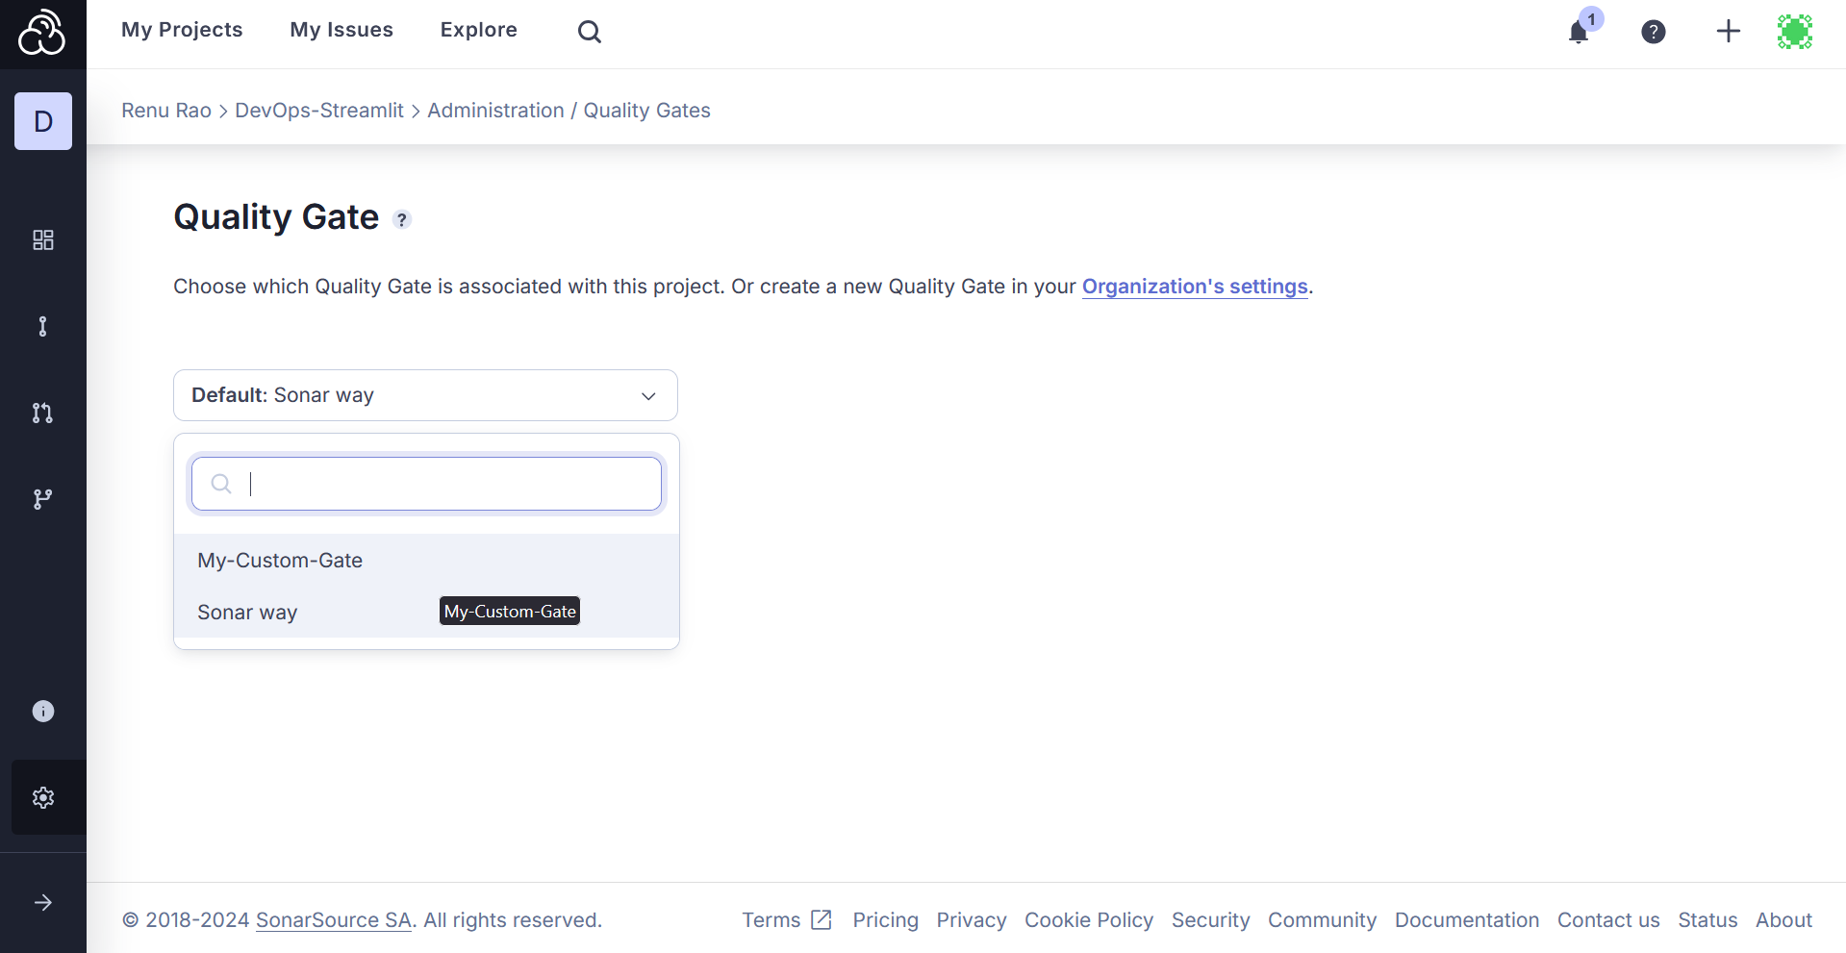

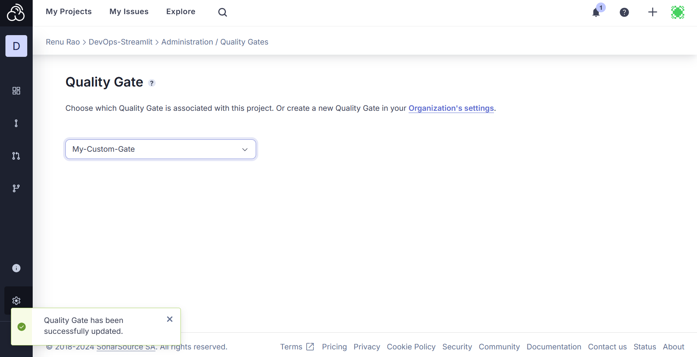

**SonarCloud + Jenkins**

Start by pulling the official image of Jenkins from docker hub

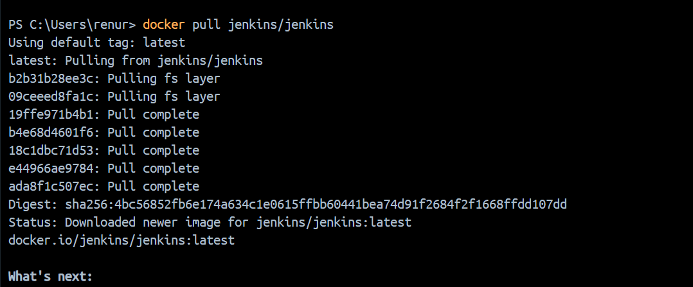

Now run the Jenkins/Jenkins container: docker run jenkins/jenkins

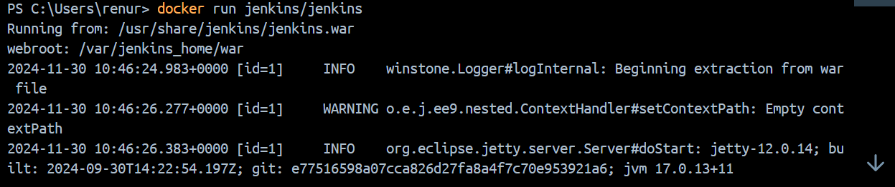

You would have got this password on the terminal

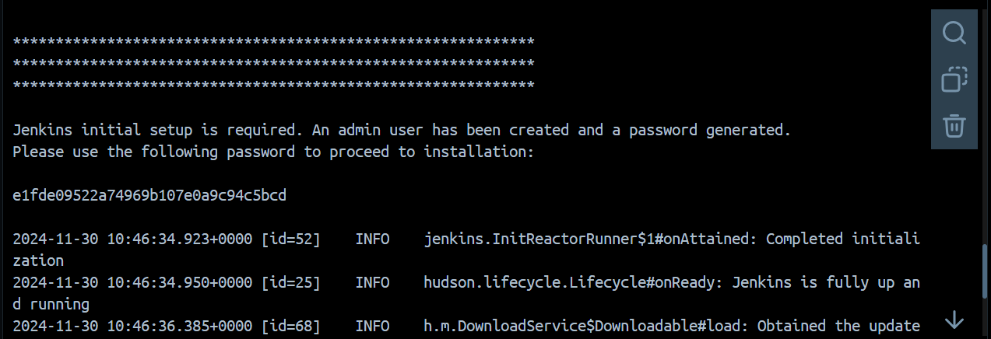

Open on localhost:8080 and enter that password

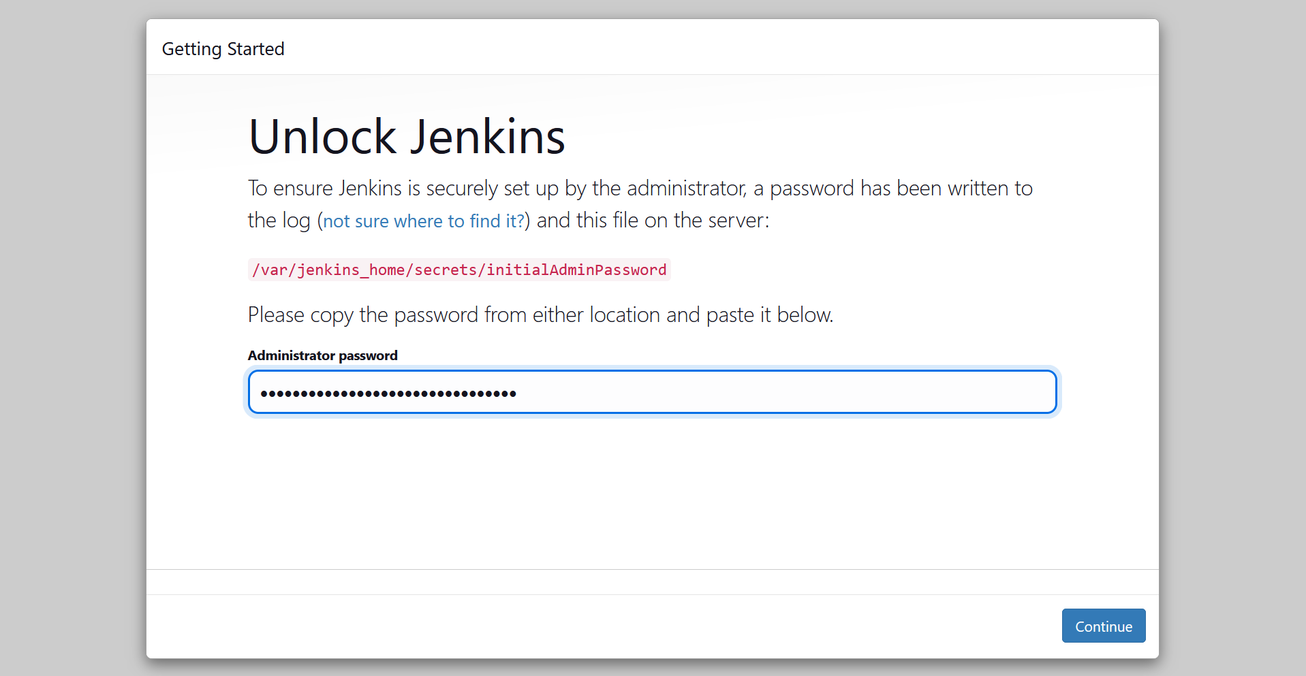

Install suggested plugins

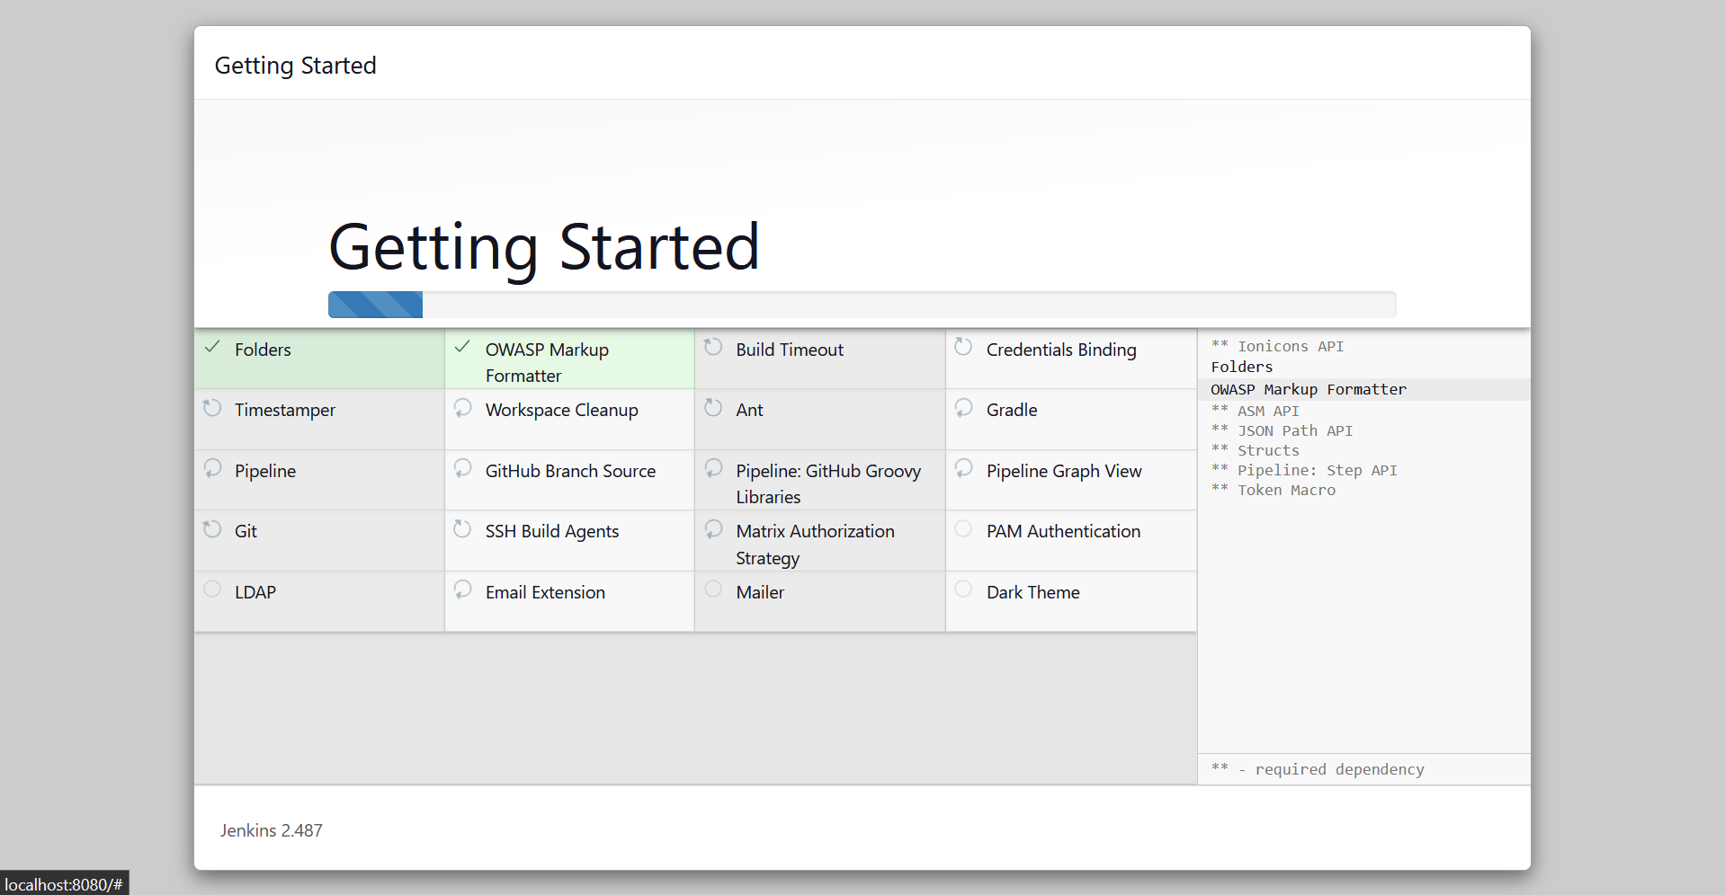

Enter your details

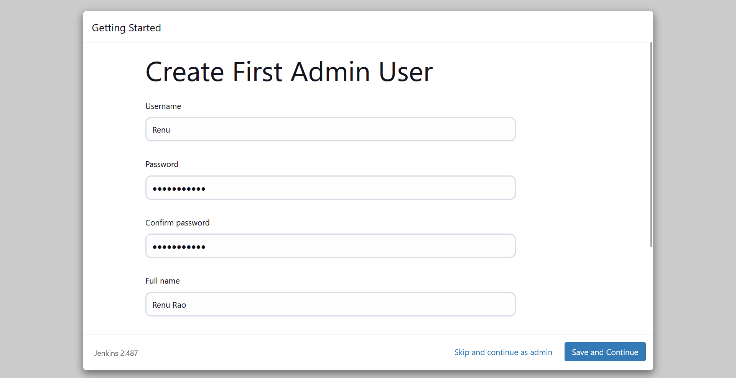

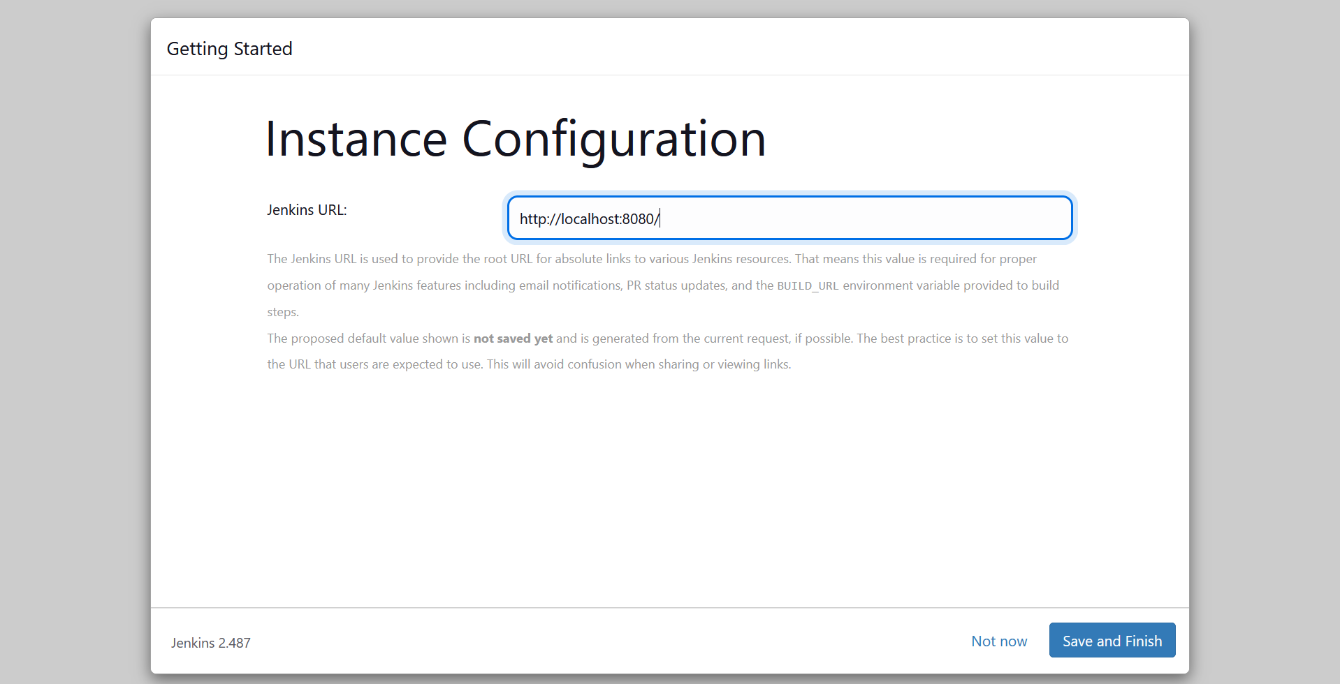

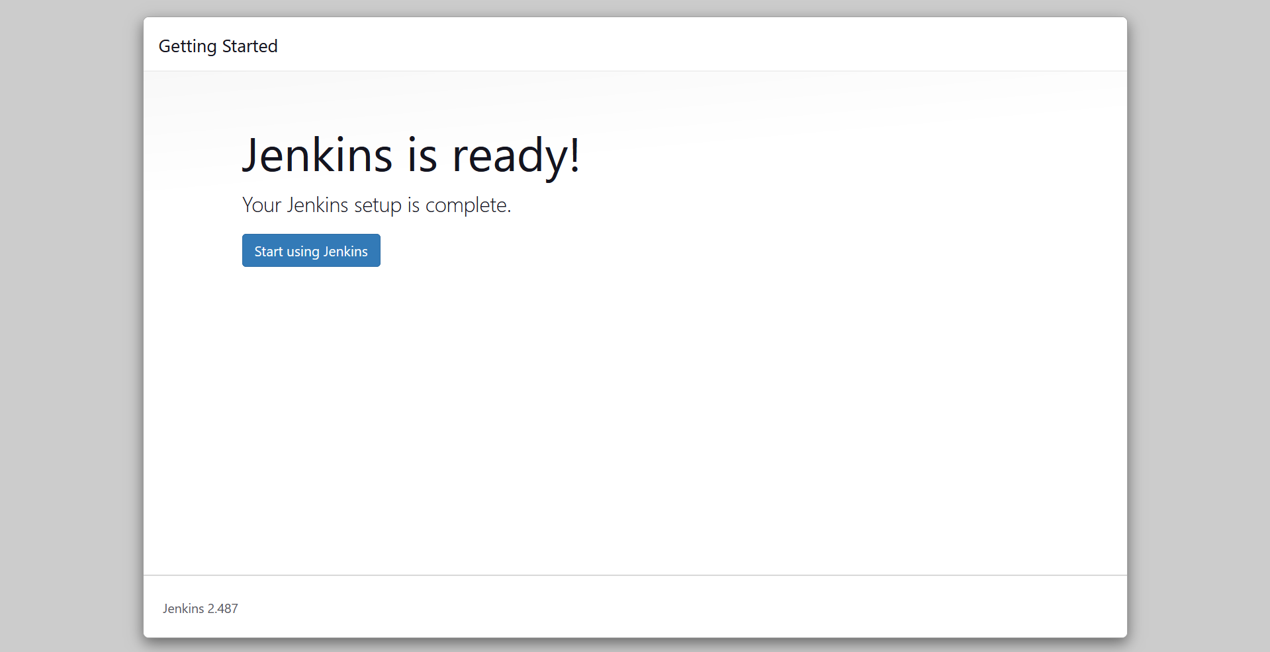

Generate a SonarCloud token

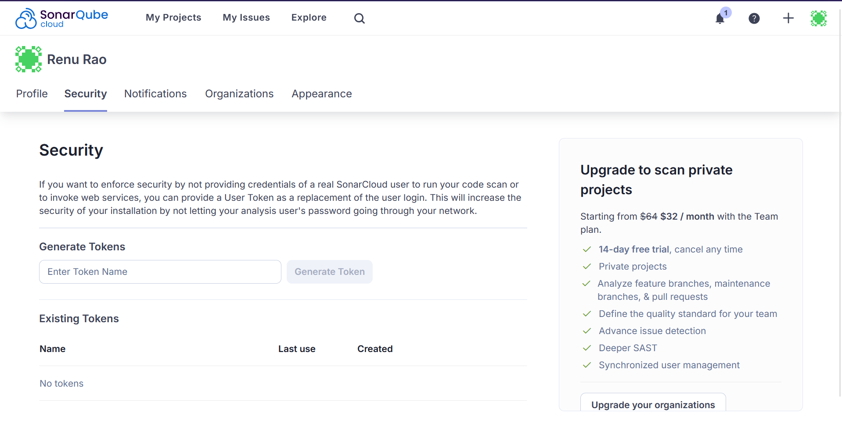

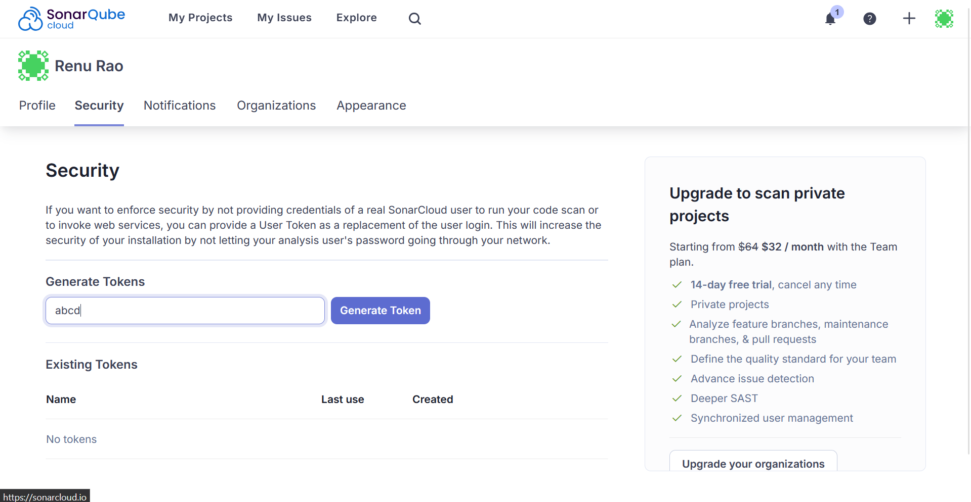

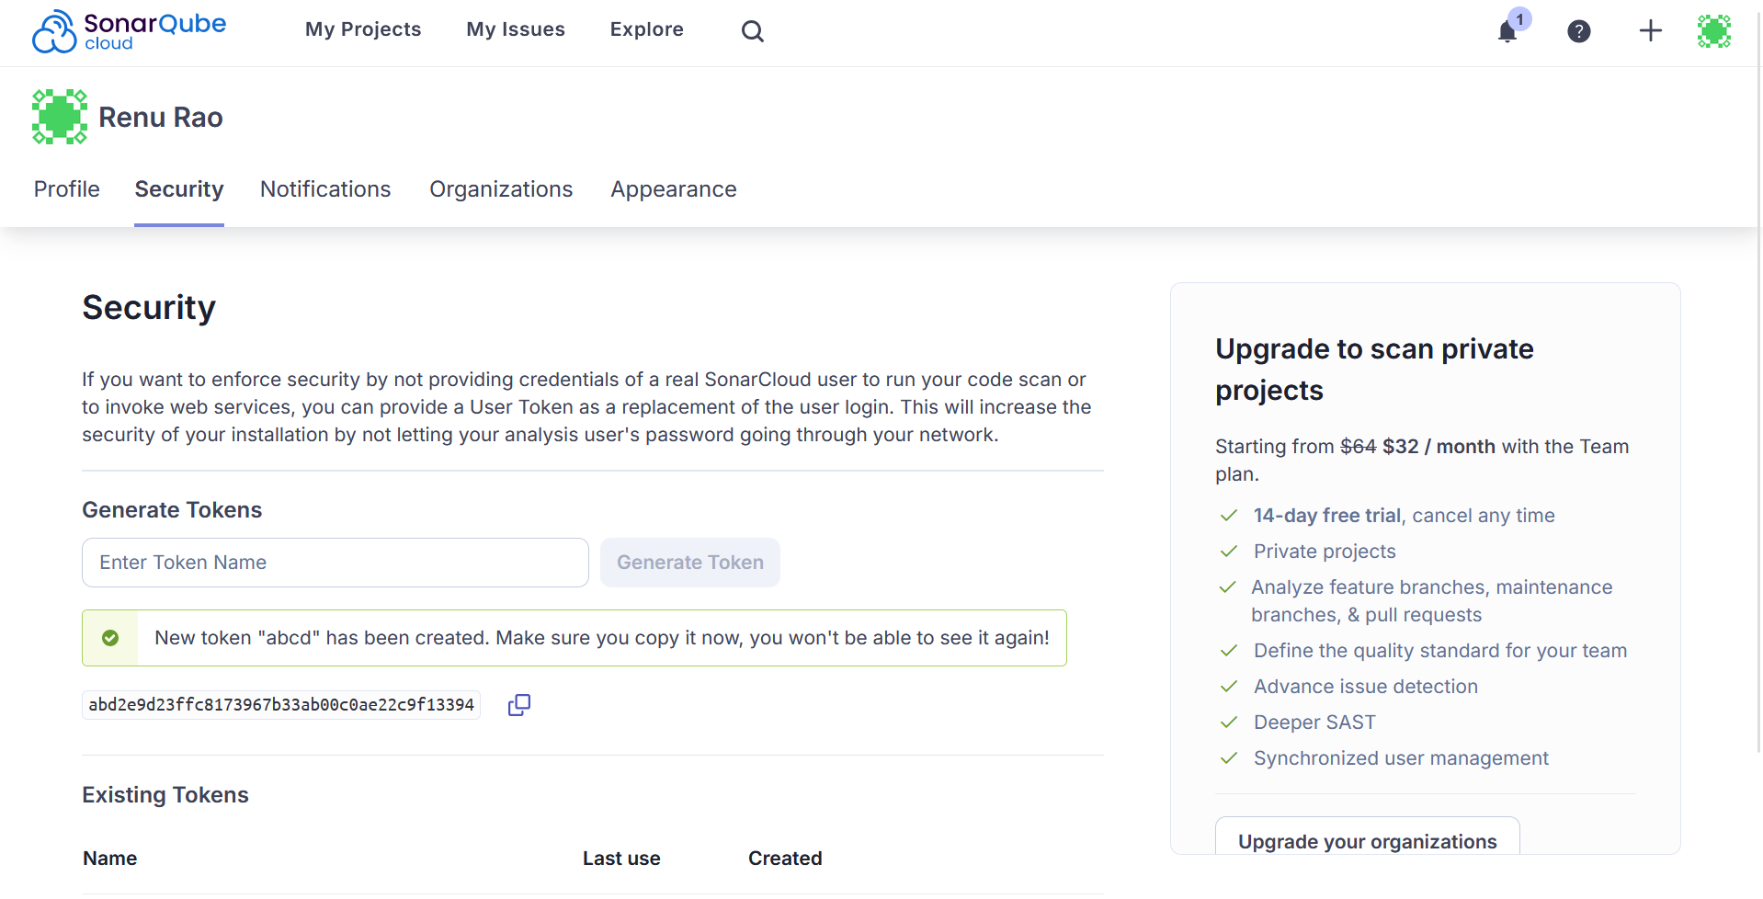

abd2e9d23ffc8173967b33ab00c0ae22c9f13394

Then go to Jenkins dashboard -> manage plugins -> install sonarqube scanner plugin

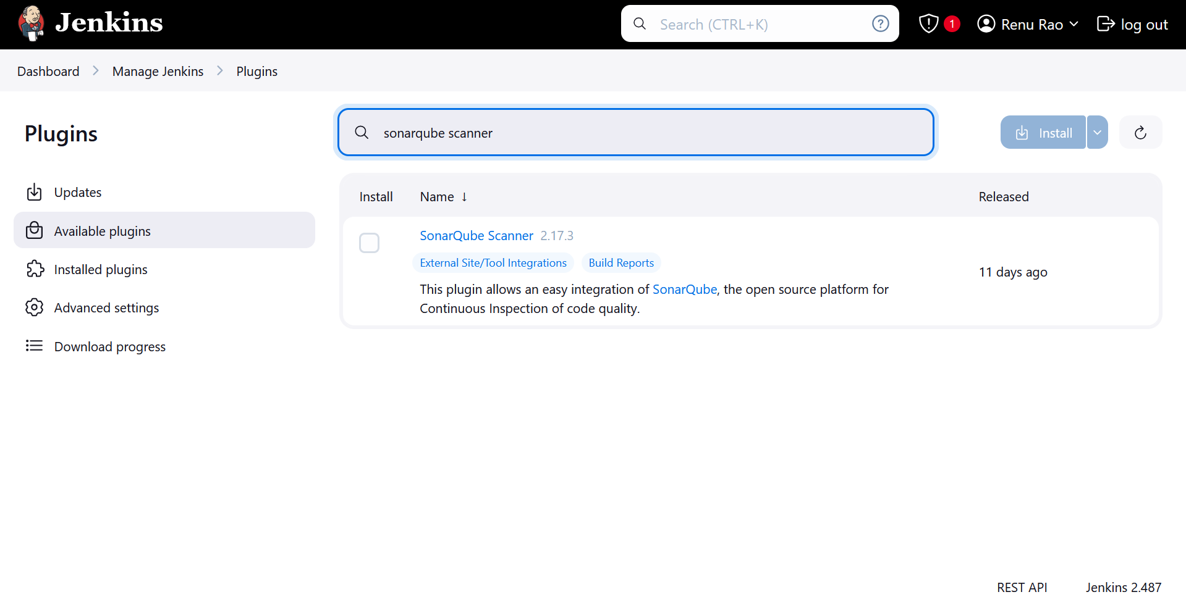

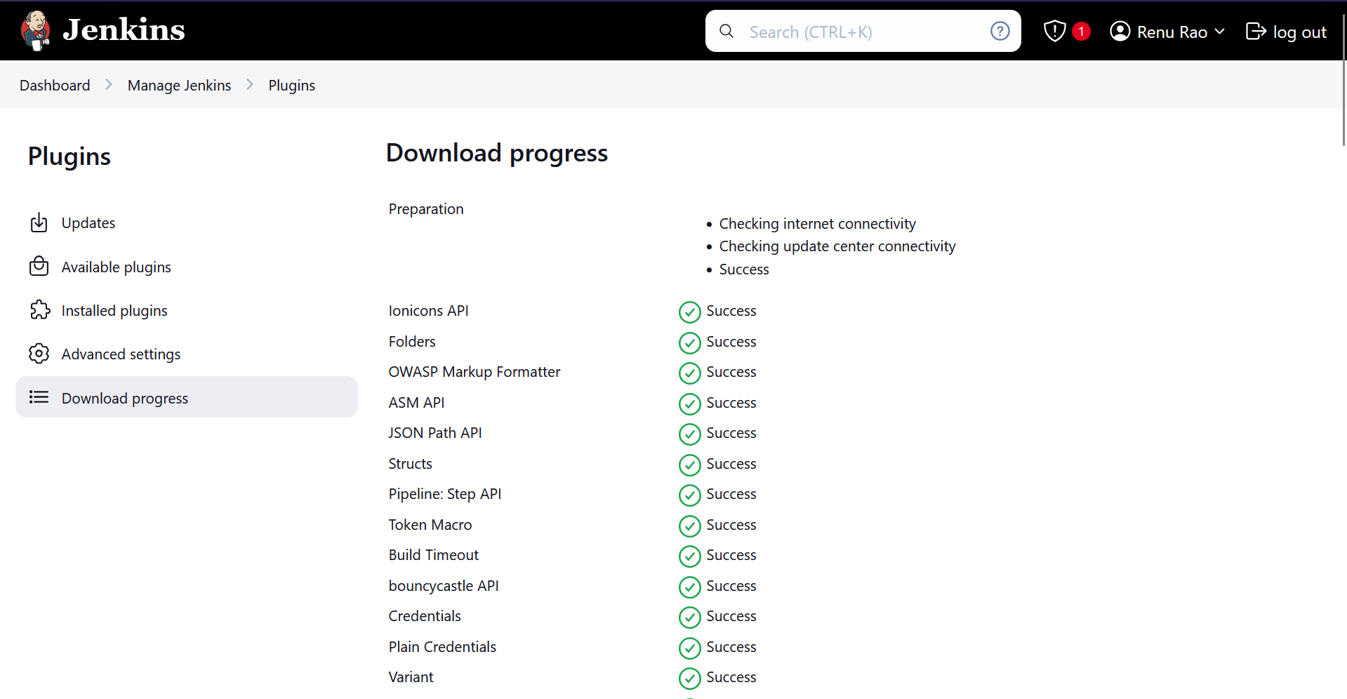

Restart Jenkins

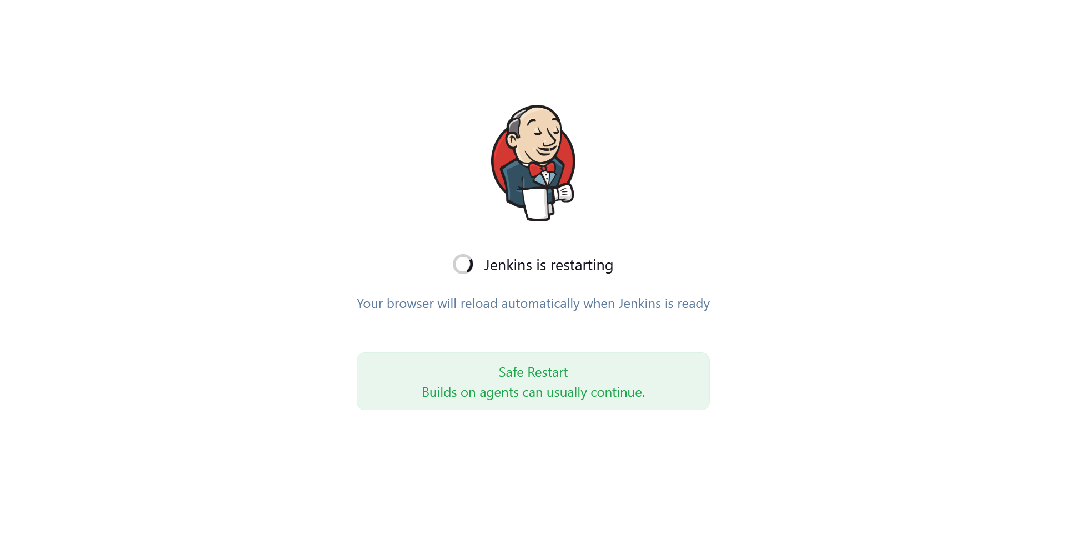

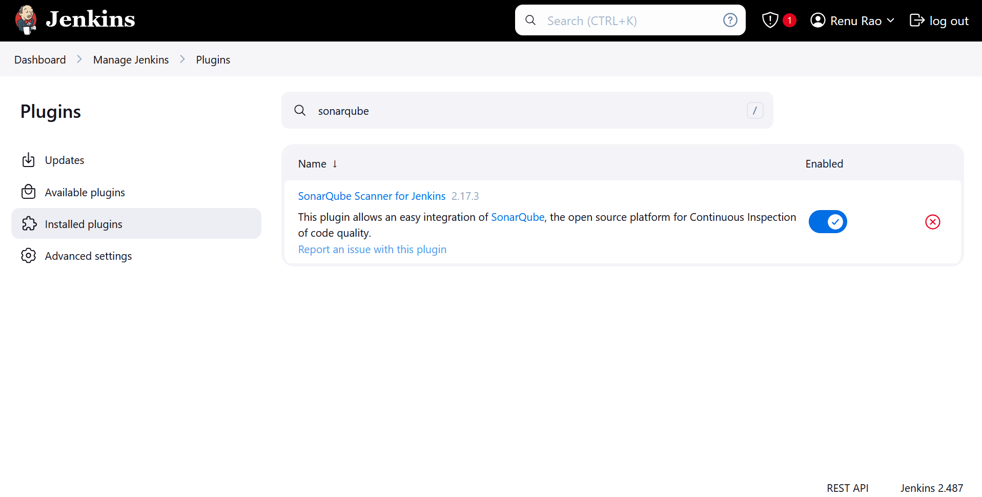

Add sonarqube token

Manage Jenkins -> Credentials

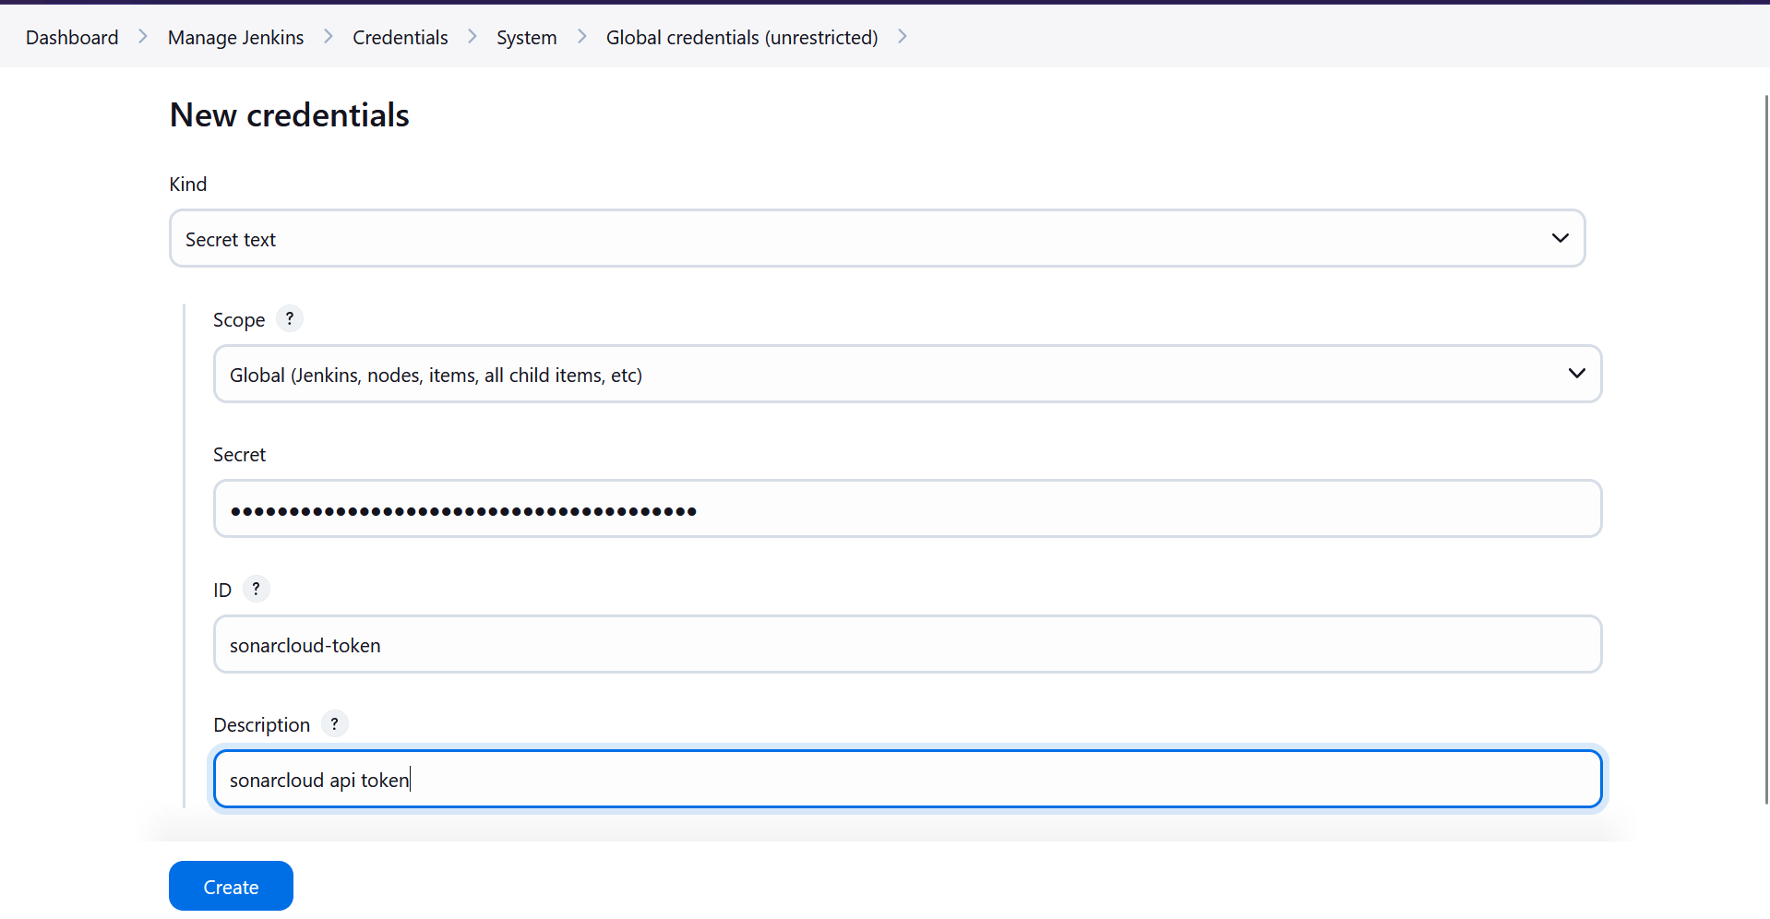

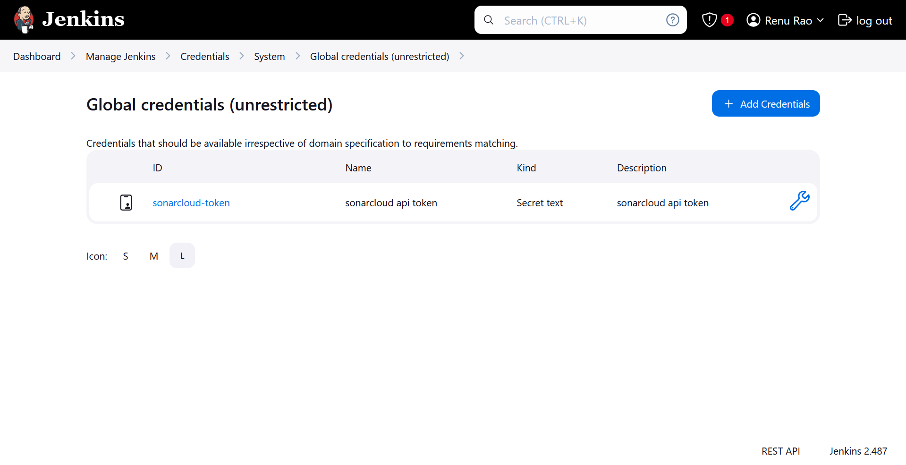

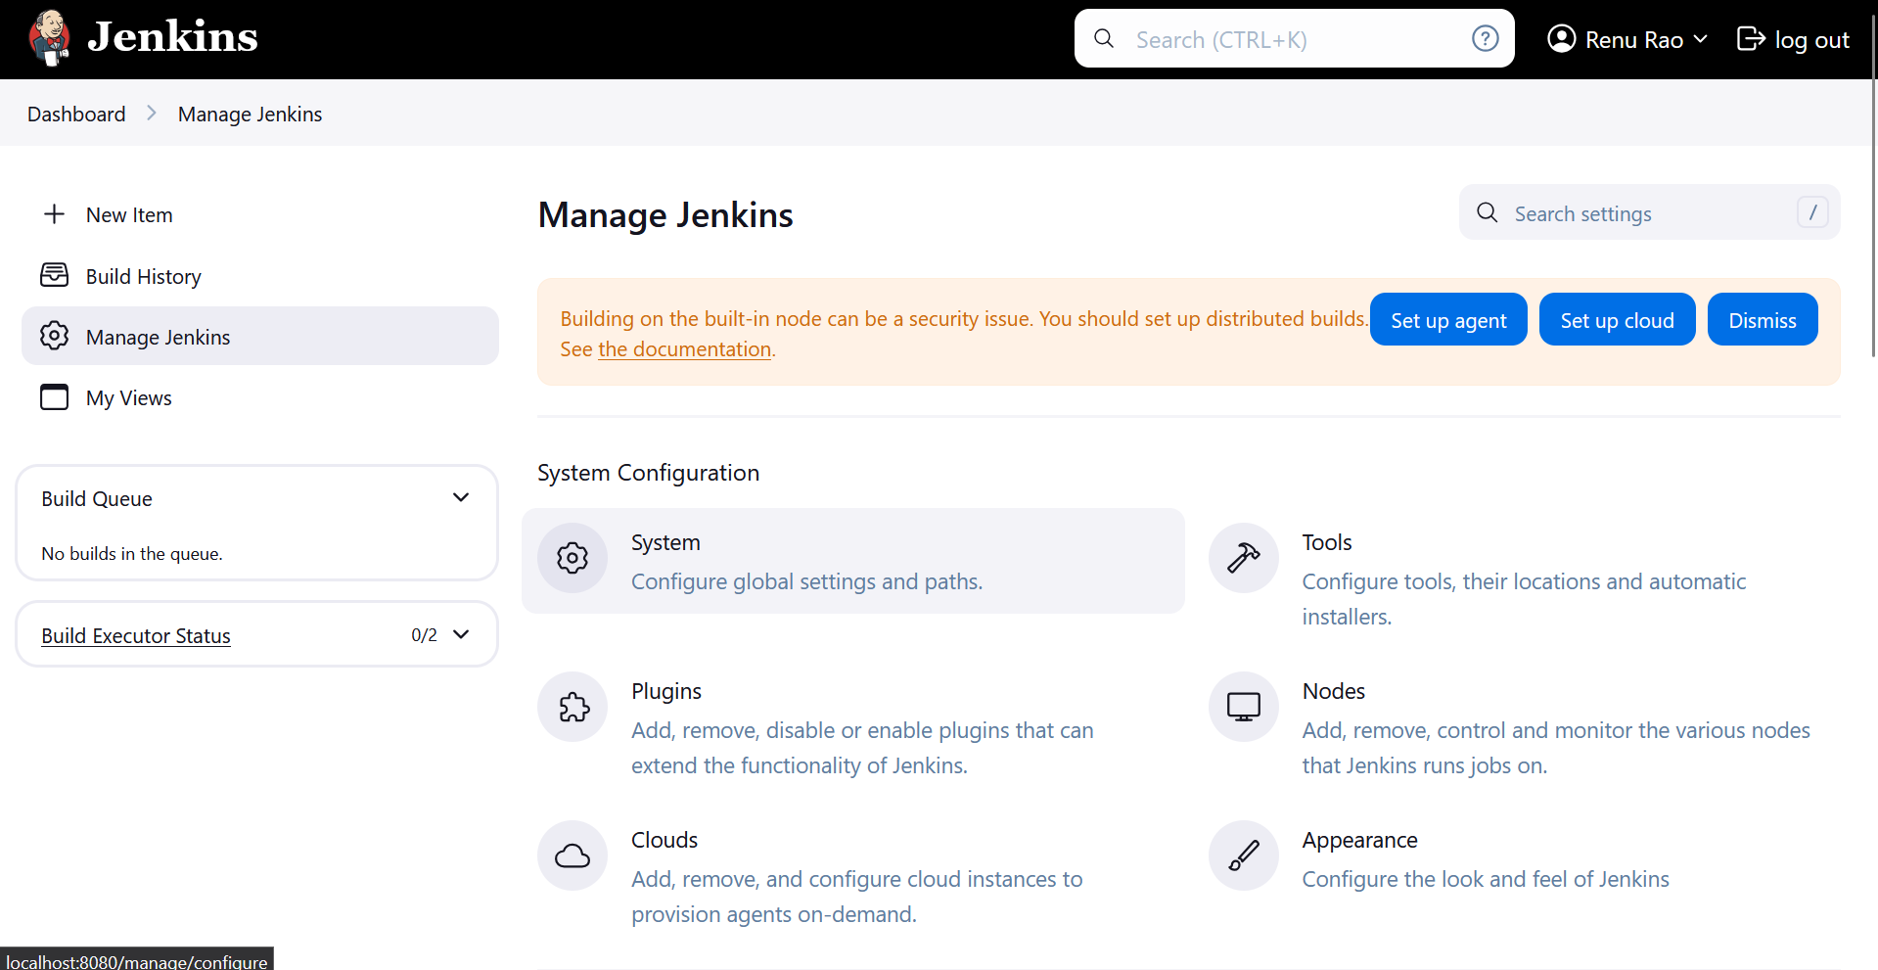

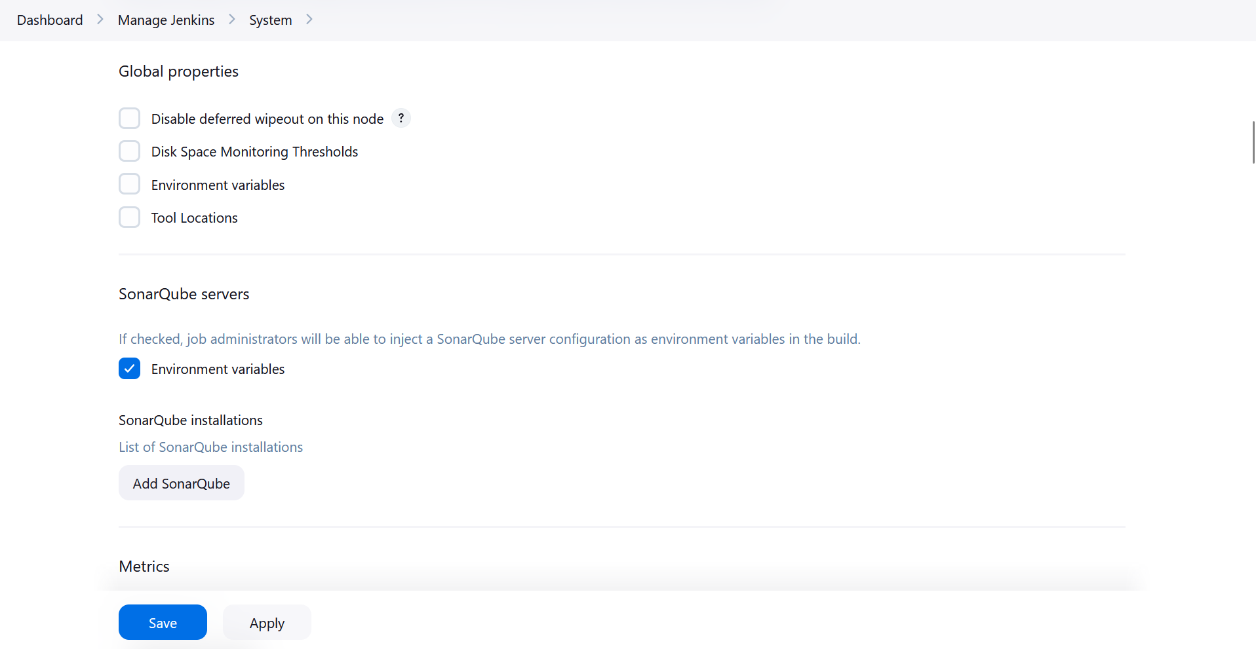

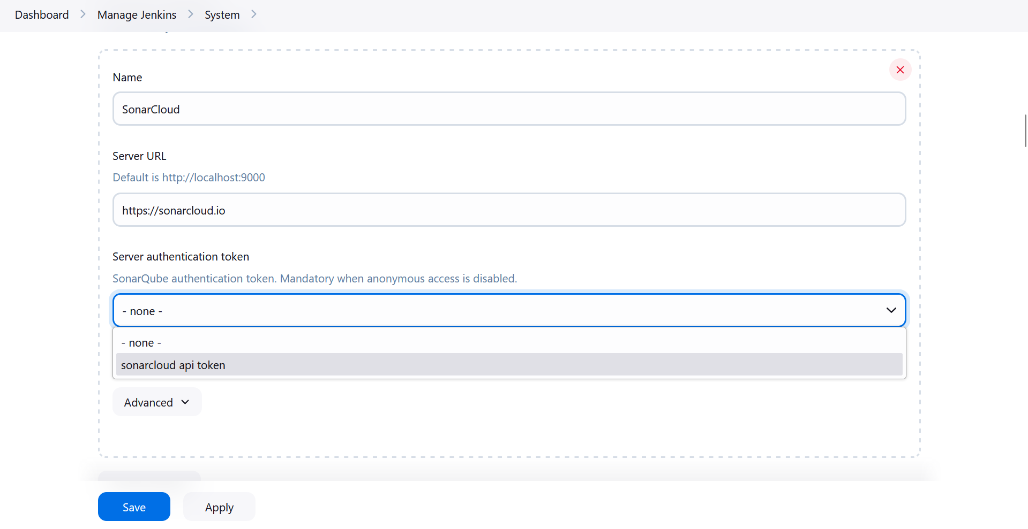

Apply & Save

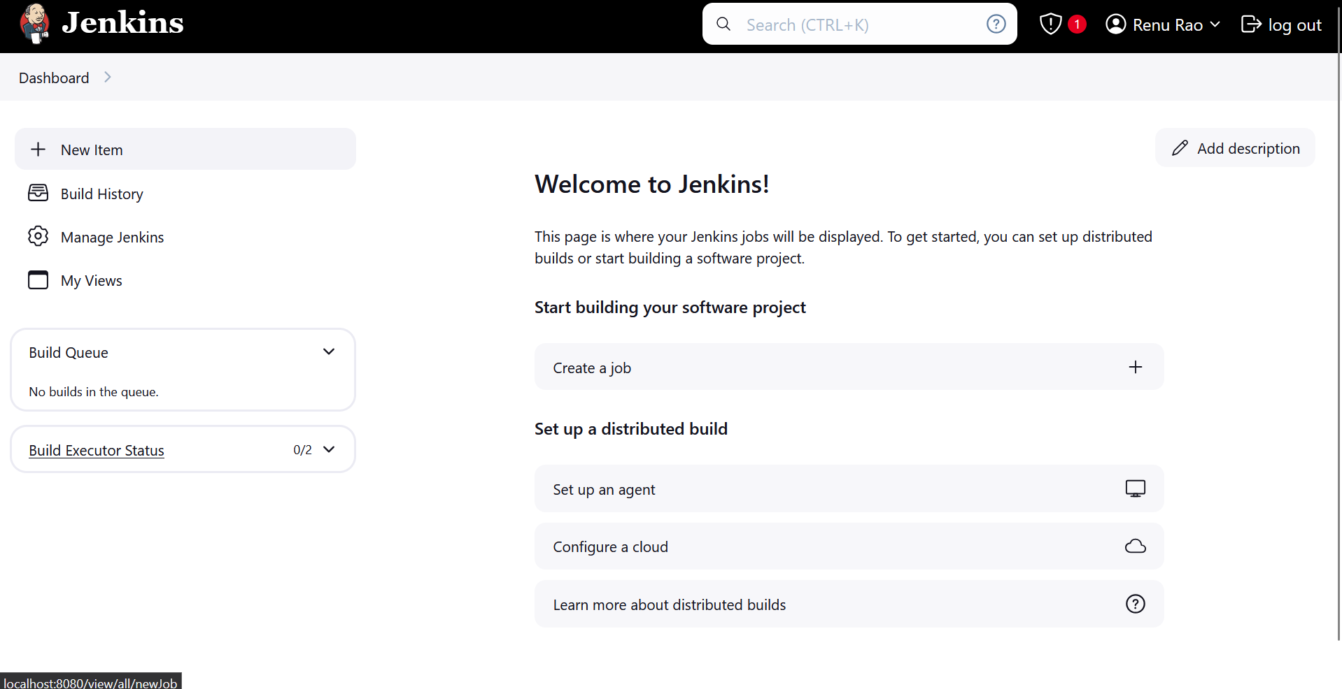

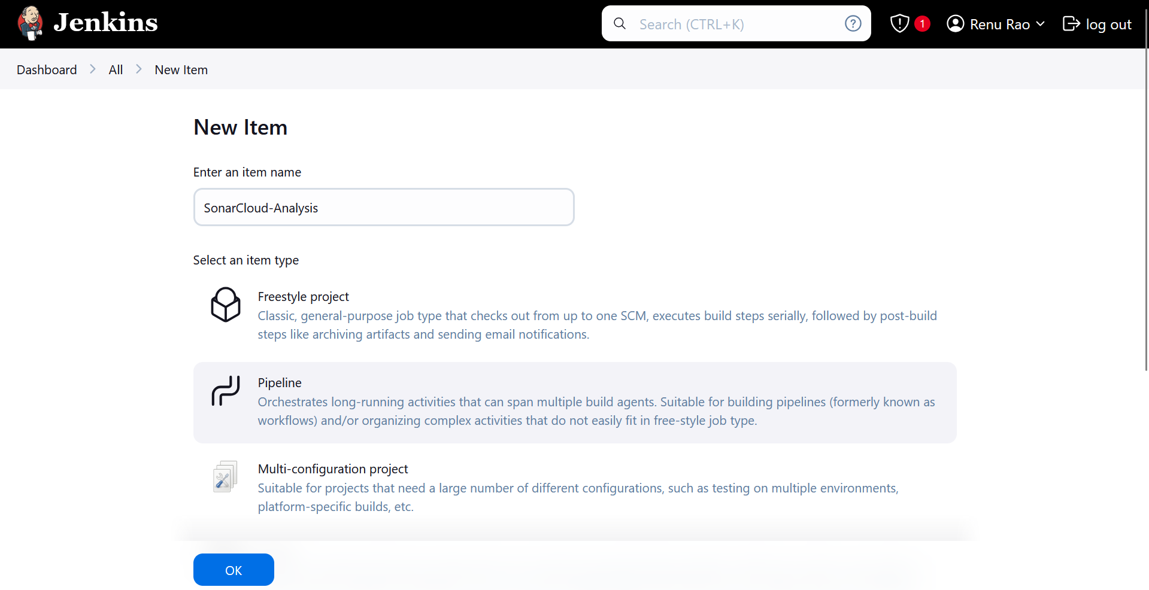

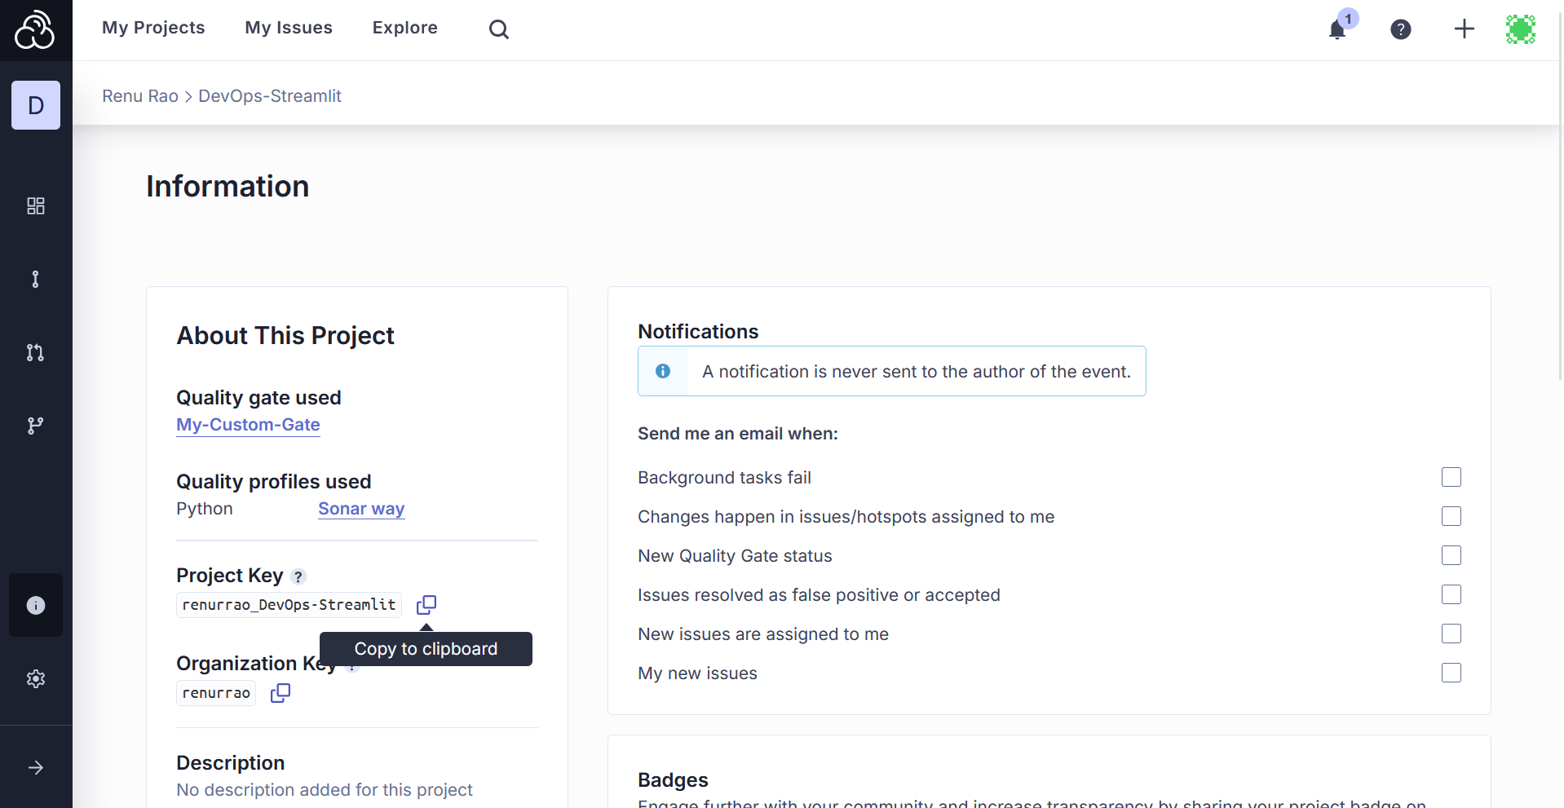

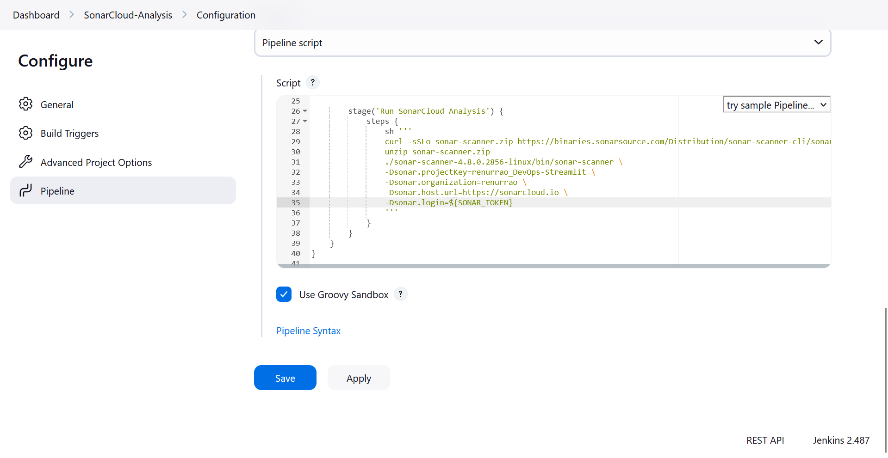

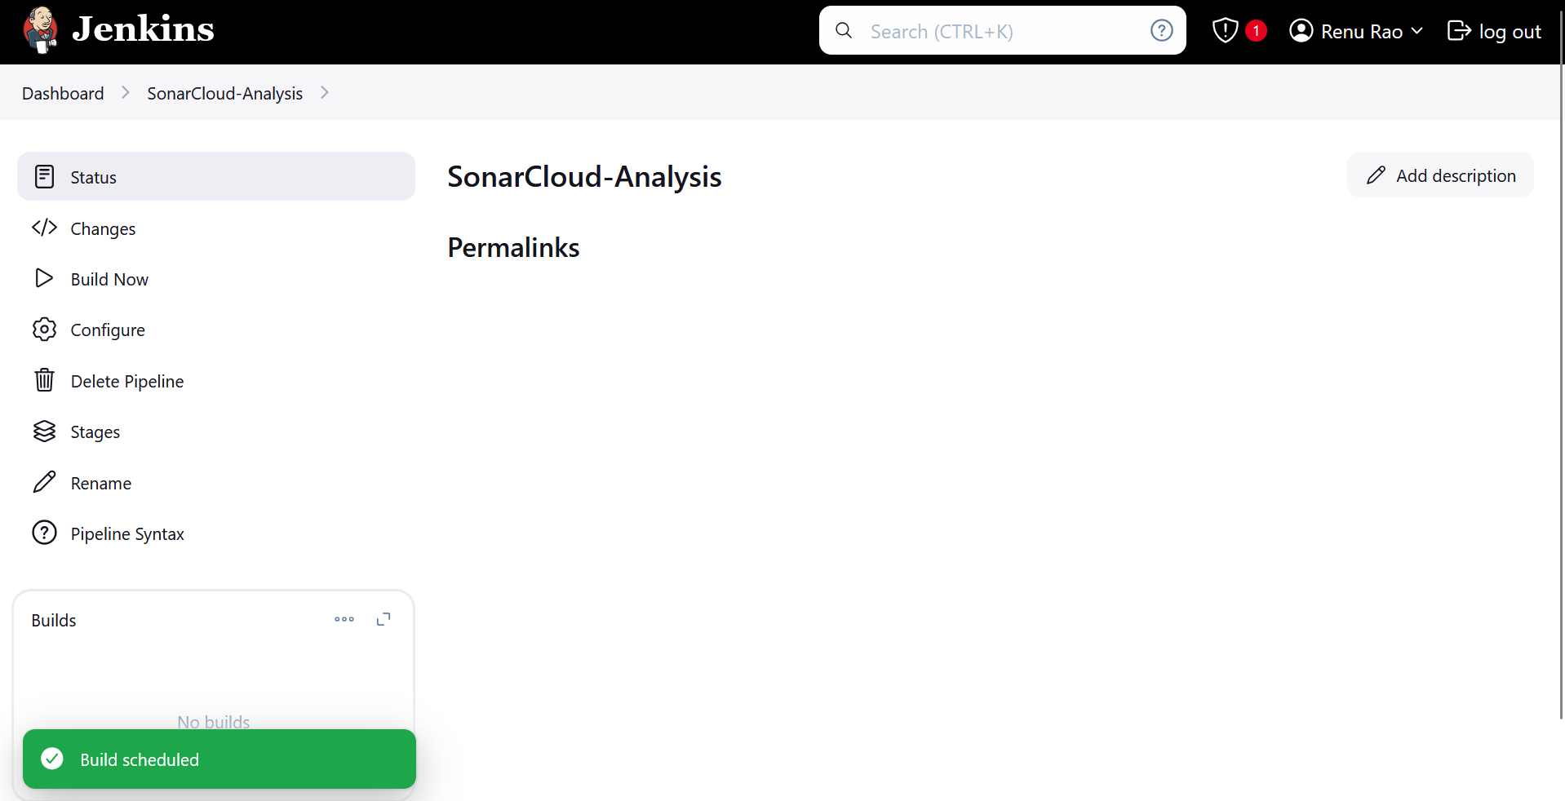

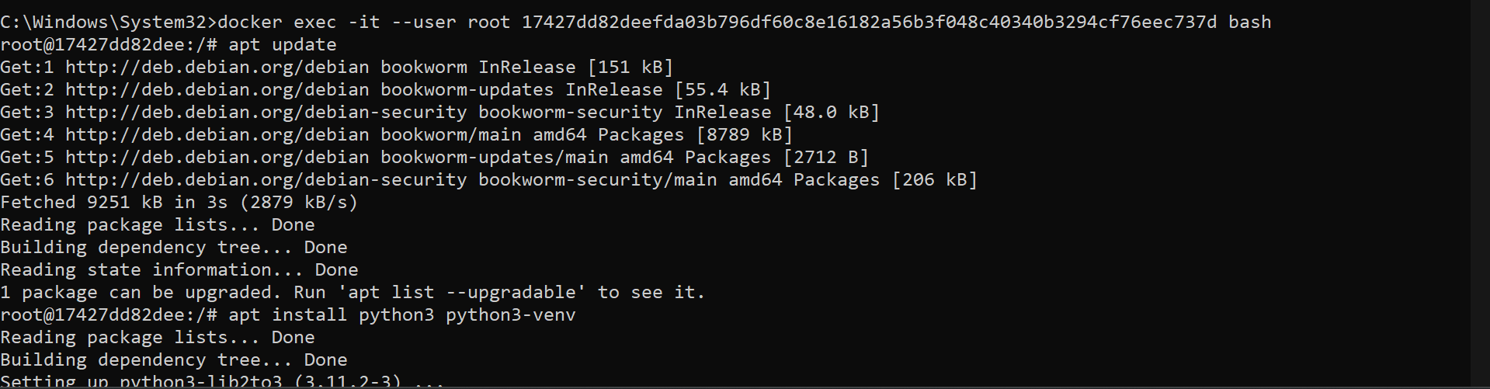

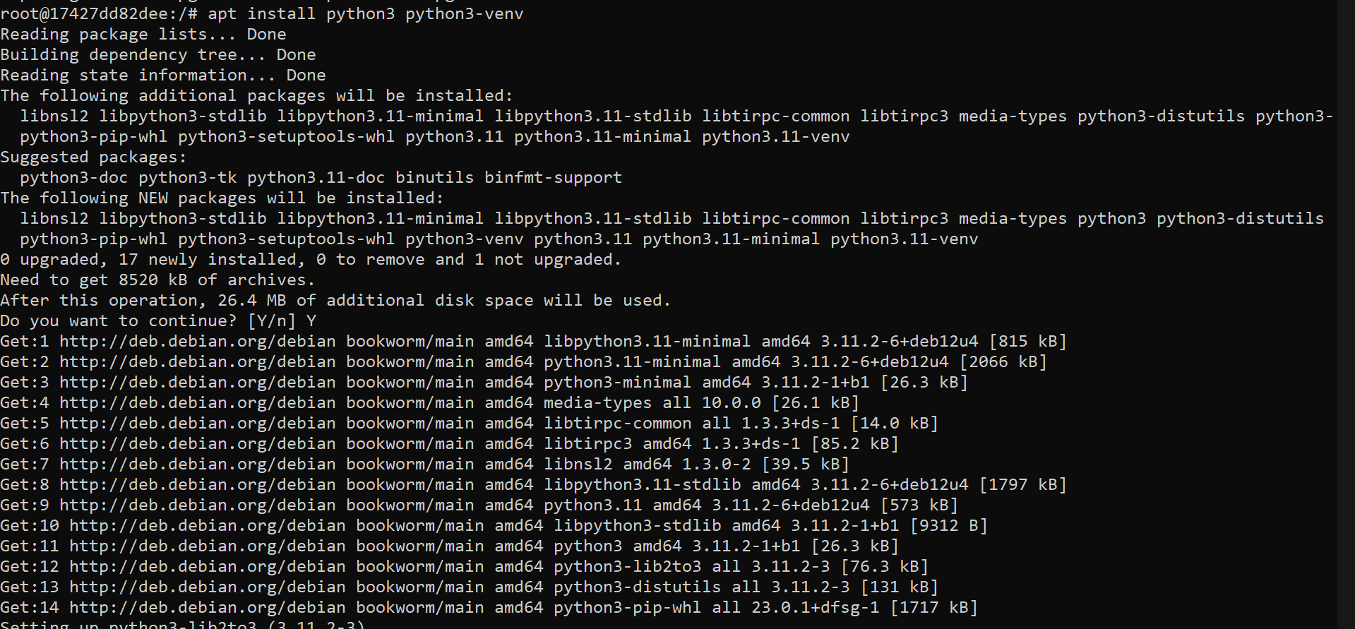

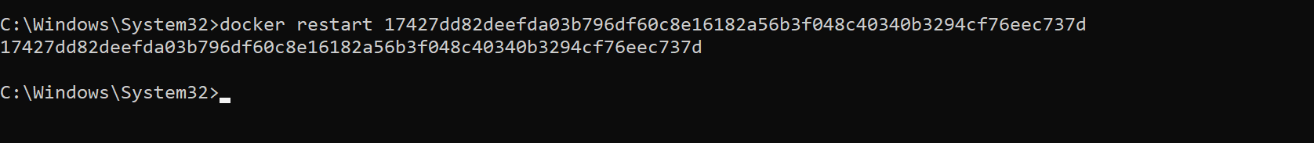

pipeline {

agent any

environment {

SONAR_TOKEN = credentials('sonarcloud-token') // The ID of your SonarCloud token in Jenkins

}

stages {

stage('Checkout Code') {

steps {

git branch: 'main', url: 'https://github.com/renurrao/DevOps-Streamlit.git'

}

}

stage('Install Dependencies') {

steps {

sh '''

python3 -m venv venv

. venv/bin/activate

pip install --upgrade pip

pip install -r requirements.txt

'''

}

}

stage('Run SonarCloud Analysis') {

steps {

sh '''

curl -sSLo sonar-scanner.zip https://binaries.sonarsource.com/Distribution/sonar-scanner-cli/sonar-scanner-cli-4.8.0.2856-linux.zip

unzip sonar-scanner.zip

./sonar-scanner-4.8.0.2856-linux/bin/sonar-scanner \

-Dsonar.projectKey=renurrao_DevOps-Streamlit \

-Dsonar.organization=renurrao \

-Dsonar.host.url=https://sonarcloud.io \

-Dsonar.login=${SONAR_TOKEN}

'''

}

}

}

}

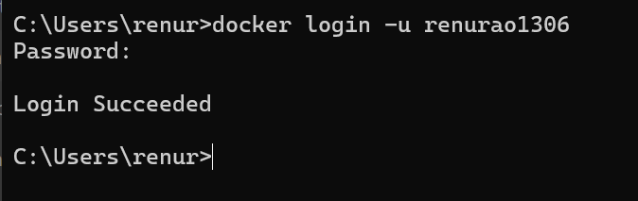

Kubernetes

Terraform

Git

Ansible